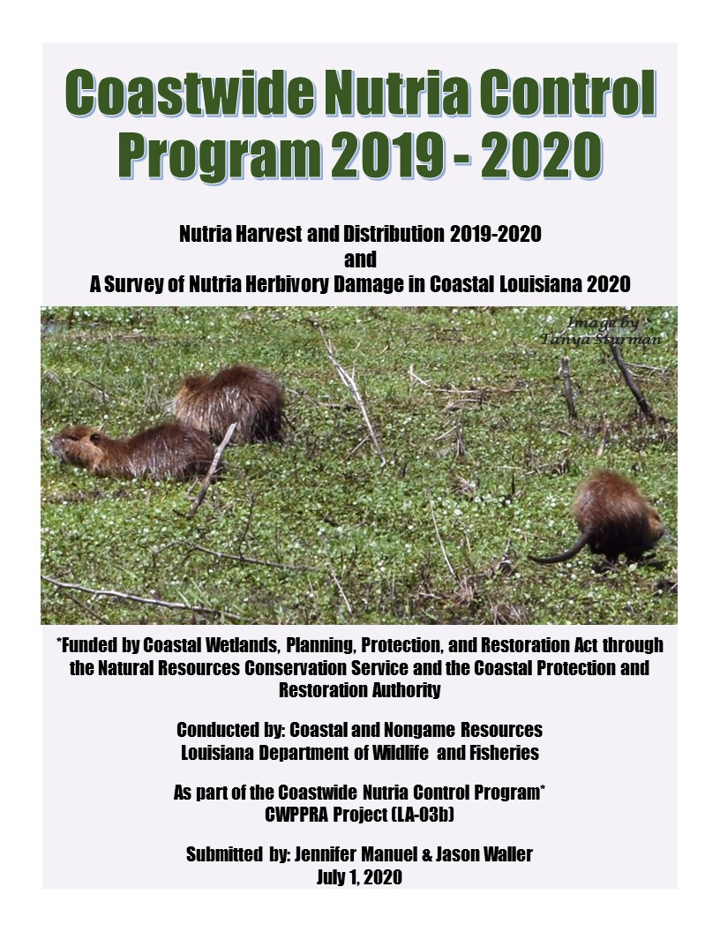

TABLE OF CONTENTS
Page
Section 1 Nutria Harvest Distribution 2019-2020--------------------------------- 4

Section 2 A Survey of Nutria Herbivory Damage in
Coastal Louisiana in 2020------------------------------------------------ 12

Section 3 Summary-------------------------------------------------------------------- 20

Figures
Figure 1 (Annual Nutria Pelt Sales and Avg. Price per Pelt) -------- 5
Figures 2A-B (Participants level of Harvest) --------------------------- 8
Figure 3 (Nutria Harvest per Month) ------------------------------------ 9
Figure 4 (Harvest by Marsh Type) ---------------------------------------10
Figure 5 (Method of Take) ----------------------------------------------- 10
Figure 6 (Method of Take by Marsh Type) --------------------------- 10
Figure 7 (Harvest by Parish) --------------------------------------------- 11
Figure 8 (Damage Type) ------------------------------------------------- 15
Figure 9 (Percentage of Damaged Acres per Parish) ----------------- 15
Figures 10A-C (Locations of Damage by Marsh Type) -------------- 16
Figure 11 (Nutria Relative Abundance Rating) ----------------------- 17
Figure 12 (Vegetative Damage Rating) -------------------------------- 17
Figure 13 (Age of Damage and Condition Rating) ------------------- 18
Figure 14 (Prediction of Recovery) ------------------------------------- 18
Figure 15 (CNCP Progress) ---------------------------------------------- 20
Figure 16 (Total Tails by Parish over all Seasons) -------------------- 23
Figure 17 (Tail Collection Data Sheet) --------------------------------- 24

Tables
Table 1 (Carcass Use) ----------------------------------------------------- 11
Table 2 (Three Years Prior to CNCP) ---------------------------------- 21
Table 3 (Sixteen Years of the CNCP) ----------------------------------- 21
Table 4 (Nutria Harvest by Parish Seasons 1-18) --------------------- 26
Table 5 (Method of Take by Parish Seasons 1-18) ------------------- 29
Table 6 (Status and Number of Nutria Herbivory Sites) ------------- 34
Table 7 (Number of Nutria Damage Sites and Acres) ---------------- 35
Tables 8 (Number of Damage Sites and Acres by Marsh Type) ---- 39
Tables 9 (Nutria Relative Abundance Rating) ------------------------- 41
Tables 10 (Vegetative Damage Rating) --------------------------------- 43
Tables 11 (Age of Damage and Condition Rating) ------------------- 45
Tables 12 (Prediction of Recovery) ------------------------------------- 47
Table 13 (2020 Nutria Veg. Damage Survey Results) --------------- 53

Appendices

Appendix A ---------------------------------------------------------------- 25
- Season Comparison Data
Appendix B ---------------------------------------------------------------- 49
- 2019 Nutria Veg. Damage Sites
- 2019-2020 Harvest and 2020 Damage Sites Map
- 2020 Veg. Damage Survey Results
- 2020 Veg. Damage Survey Data Sheet
- Code Key for Veg. Damage Survey Data Sheet

Section 1

Nutria Harvest Distribution for 2019-2020

Introduction

The nutria (Myocastor coypus) is a large semi-aquatic rodent indigenous to South America. The first introduction of nutria to North America occurred in California in 1899; however, it was not until the 1930's that additional animals were introduced in seven other states primarily for fur farming. These fur farms failed during the Second World War as a result of poor pelt prices and poor reproductive success. After the failures of these fur farms, nutria were released into the wild. Seventeen states in the US now have feral nutria populations.

The Gulf Coast nutria population originated in Louisiana in the 1930’s from escapes and releases from nutria farms. Populations first became established in the western coastal portion of the state and then later spread to the east through natural expansion coupled with stocking. During the mid-1950s, muskrat populations were declining, nutria had little fur value, and serious damage was occurring in rice fields in southwestern Louisiana and sugarcane fields in southeastern Louisiana; farmers complained about damage to crops and levee systems, while muskrat trappers blamed the nutria for declining numbers of muskrats. In 1958, the Louisiana Legislature placed the nutria on the list of unprotected wildlife and created a $0.25 bounty on every nutria killed in 16 south Louisiana parishes, but funds were never appropriated.

Research efforts were initiated by the federal government in the southeastern sugarcane region of the state to determine what control techniques might be successful. This research conducted by the U.S. Fish and Wildlife Service during the 1960's examined movements in relation to sugarcane damage and recommended shooting, trapping, and poisoning in agricultural areas. Ted O'Neil, Chief of the Fur and Refuge Division, Louisiana Department of Wildlife and Fisheries (LDWF), believed that the problem could only be solved through the development of a market for nutria pelts. A market for nutria developed slowly during the early 1960's and by 1962 over 1 million pelts were being utilized annually in the German fur trade. The nutria became the backbone of the Louisiana fur industry for the next 20 years, surpassing the muskrat in 1962 in total numbers harvested. In 1965, the state legislature returned the nutria to the protected list. As fur prices showed a slow rise during most of the 1970's and early 1980's, the harvest averaged 1.5 million pelts and complaints from agricultural interest became uncommon. From 1971 through 1981 the average annual value of the nutria harvest to the coastal trappers was $8.1 million. The nutria harvest in Louisiana from 1962 until 1982 remained over 1 million annually. The harvest peaked in 1976 at 1.8 million pelts worth $15.7 million to coastal trappers (Figure 1).

The nutria market began to change during the early 1980's. In 1981-1982, the nutria harvest dropped slightly below 1 million. This declining harvest continued for two more seasons; then in the 1984-1985 season, the harvest jumped back up to 1.2 million. During the 1980-1981 season, the average price paid for nutria was $8.19. During the 1981-1982 season, the price dropped to $4.36 and then in 1982-1983, the price dropped to $2.64. Between the 1983-1984 season and the 1986-1987 season, prices fluctuated between $3.00 and $4.00. Then in 1987-1988 and again in 1988-1989 prices continued to fall (Figure 1). From 1982 through 1992 the average annual value of the nutria harvest was only $2.2 million. Between 1988-1989 and 1995-1996 the number of nutria harvested annually remained below 300,000 and prices remained at or below a $3.00 average.

Due to a strong demand for nutria pelts in Russia in both 1996-1997 and in 1997-1998, 327,286 nutria were harvested at an average price of $4.13 and 359,232 nutria were harvested at an average price of $5.17 during those seasons respectively. In September 1998, the collapse of the Russian economy and general instability in the Far East economies weakened the demand for most wild furs including nutria. The demand for nutria pelts in Russia declined quickly due to the devaluation of the Russian ruble. During the 1998-1999 trapping season, pelt values fell to $2.69 and harvest decreased to only 114,646, less than one-third of the previous year. During the 1999-2000 trapping season there was virtually no demand for nutria pelts. The harvest decreased to 20,110 nutria. This was, by far, the lowest nutria harvest on record since the mid-1950s. The number of nutria harvested in 2000-2001 trapping season increased to 29,544. The value of nutria pelts decreased to $1.75 during the 2001-2002 season, prompting another decrease in harvest to 24,683 nutria. The nutria fur market has never recovered.

Figure 1. Louisiana fur market 1943 – 2002 (the season prior to CNCP implementation).

During the strong market period for nutria pelts, there were no reports of wetland damage caused by nutria. However, before the market developed and after the market declined, reports of marsh vegetation damage from land managers became common. Such complaints began in 1987 and became more frequent during the early 1990’s. In response, the Fur and Refuge Division of the Louisiana Department of Wildlife and Fisheries (LDWF) initiated limited aerial survey flights, particularly in southeastern Louisiana. Survey flights of Barataria and Terrebonne basins were conducted during the 1990’s, with initial support from Barataria-Terrebonne National Estuary Program (BTNEP) and later support from Coastal Wetlands Planning, Protection and Restoration Act (CWPPRA). From 1993 to 1996 these flights showed acres of damage increasing from approximately 45,000 to 80,000 acres within the basins. The first CWPPRA funded coastwide survey, conducted in 1998, showed herbivory damage areas totaling approximately 90,000 acres. By 1999 this coastwide damage had increased to nearly 105,000 acres. This rapid and dramatic increase in damaged acres prompted LDWF to pursue funding for the Coastwide Nutria Control Program (CNCP) in January 2002.

The project is funded by the CWPPRA through the Natural Resources Conservation Service (NRCS) and the Coastal Protection and Restoration Authority (CPRA) with the LDWF as the lead implementing agency. Task one requires LDWF to conduct an annual aerial survey to evaluate the herbivory damage caused by nutria. Task two of the CPRA and LDWF Interagency Agreement No. 2511-02-29 for the CNCP requires LDWF to conduct general project operation and administration. LDWF is required to 1) conduct and review the registration of participants in the CNCP; 2) establish collection stations across coastal Louisiana; 3) count valid nutria tails and present participants with a receipt/voucher; 4) deliver tails to an approved disposal facility and receive documentation that ensures the nutria will be properly disposed of and shall not leave the facility; and 5) process and maintain records regarding participants, number and location where tails were collected. Task 3 requires LDWF to provide incentive payments to program participants and task 4 requires LDWF to provide a report regarding the distribution of the harvest by township.

The program area is coastal Louisiana bounded to the north by Interstate-10 from the Texas state line to Baton Rouge, Interstate-12 from Baton Rouge to Slidell, and Interstate-10 from Slidell to the Mississippi state line. The project goal is to significantly reduce damage to coastal wetlands attributable to nutria herbivory by removing 400,000 nutria annually. This project goal is consistent with the Coast 2050 common strategy of controlling herbivory damage to wetlands. The method chosen for the program is an incentive payment to registered trappers/hunters for each nutria tail delivered to established collection centers. Initially, registered participants were given $4.00 per nutria tail. To encourage participation, the payment was increased to $5.00 per tail in the 2006-2007 season and $6.00 before the 2019-2020 season.

Methods

The application for participation in the CNCP was developed in July 2002 but is reviewed annually and updated as needed. It was made available through the LDWF offices and the www.nutria.com website. Past participants were automatically sent an application in September of 2019. In order for a participant to be qualified, the individual must complete the application, obtain written permission from a landowner or land manager with property in the program area, complete a W-9 tax form and provide LDWF with a complete legal description of the property to be hunted or trapped. A map outlining the property boundaries was an added requirement of participants beginning with the 2003-2004 season. Once an applicant was accepted, the participant was mailed information on the program’s regulations, collection sites for nutria tails, contact information and a CNCP registration card.

Coastal Environments Inc. (CEI) was selected as the contractor to develop and maintain the program database, collect nutria tails, and distribute incentive payment checks to participants for tail harvests. The contract with CEI, which began with the 2002-2003 season, was extended to include the 2003-2004 through 2006-2007 seasons, with the option to renew for 3 years thereafter. CEI was awarded the contract again in 2010, 2015 and again in 2020. All were three year contracts with the option to renew an additional two years. Tail collection sites were originally established at Rockefeller Refuge, Abbeville, Berwick (Morgan City), Houma, and Luling. Slidell and St. Bernard has since been added. Collections were made once a week at most sites except Abbeville and Rockefeller were by appointment only, Slidell and St. Bernard were scheduled biweekly.

Louisiana’s open trapping season began on November 20, 2019. Nutria tail collections began November 21, 2019 and were scheduled to continue through April 3, 2020, which was 1 week after the season closed. The last two weeks of collections had to be cancelled due to the Covid 19 shelter-in-place order which went into effect on March 22, 2020. After the shelter-in-place order was lifted, two additional collection dates were added on June 11th and 12th, 2020 to give participants a chance to turn in any remaining tails. Collections were made utilizing a 16 foot by 8 foot trailer containing a freezer, sorting table and desk. Participants reported to the collection site of their choice, presented their nutria control program registration card, and presented their tails to a CEI representative.
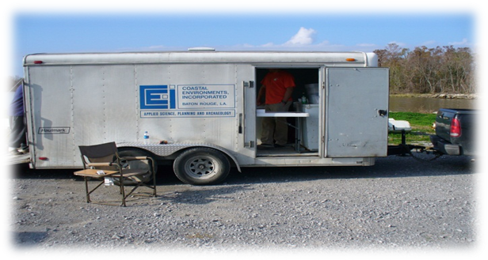
One CEI representative conducted an exact count of the nutria tails, which was then verified with the participant to ensure they were in agreement. At that time, the counted tails were placed into a plastic garbage bag labeled with the participant’s CNCP registration number and the number of tails contained in that bag. Another CEI representative filled out a voucher on a tablet PC for the number of tails delivered, checking to make sure the mailing address of the participant was correct. The participant was asked a wide range of questions including method of take, location of take, and method of disposal (Figure 17). When complete, the voucher was signed using a stylus by the participant who would also indicate on a detailed map of their lease the location or locations where the nutria were harvested. The CEI representative would use a stylus to draw a polygon around the indicated area in a mapping program and save an electronic copy of the completed voucher. A copy of the voucher was printed and given to the participant. LDWF personnel conducted random audits of collected tails to ensure accuracy in counting and incentive payments.
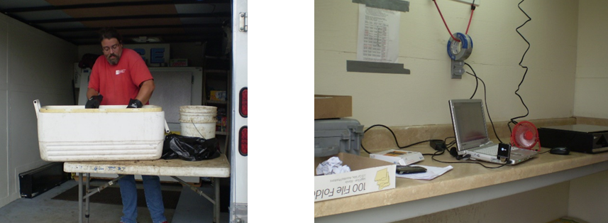

The information on the voucher was transferred electronically to the CEI main offices via an FTP site for analysis and quality control. The data transfer occurred at the end of each collection day. Collected tails were transported to the BFI waste storage facility in Sorrento, Louisiana, at the end of each collection week or more frequently if necessary. The CEI representative checked in at a guard station where the vehicle containing the tails was weighed. The vehicle was also weighed when exiting the disposal site in order to calculate the exact amount of waste deposited at the facility. The tails were deposited into a biohazard waste pit under supervision of a BFI employee. The number of bags disposed, as well as weight deposited, was recorded on a receipt given to the CEI representative. Copies of the receipts for all disposals made were supplied to LDWF.

The digitized vouchers and maps went through a rigorous QA/QC process each week which would end with the data being compiled and sent in a weekly report to LDWF detailing each transaction, including digital maps exported from ArcMap 10.4 of that week’s trapped/hunted areas. Each Monday morning, after receiving a weekly report and bill, LDWF sent a payment to CEI for the amount of tails collected and services rendered. CEI in turn sends participants checks through the mail for the amount of tails turned in. Louisiana’s open trapping season ended on March 31, 2020, and nutria tail collections continued until the start of the shelter-in-place order and then resumed for June 11th and 12th, 2020 after the shelter-in-place order was lifted. After the conclusion of the season, CEI provided LDWF with all the transaction information for the entire season from November to March. This final report contains information recorded on the vouchers, the digitized trapped/hunted area, the nutria control program database and an ArcMap project map with related information.

Results and Discussion

Participant Totals
We registered a total of 424 participants in the program for the 2019-2020 season. A total of 245,865 nutria tails worth $1,475,190 in incentive payments were collected from 259 active participants. The fewest number of tails turned in by a single participant was 3 and the greatest number of tails by a single participant was 12,281. Approximately 34% of active participants turned in 800 or more tails (Figure 2A). Of the 89 participants who turned in 800 or more tails, 9% turned in more than 4,000 tails (Figure 2B).

Figure 2A. Participant level of harvest for all 259 active participants.

Figure 2B. Participant level of harvest for the 89 participants who harvested more than 800 tails.

Harvest by Month
The 2019-2020 trapping season began November 20th, 2019 and continued through March 31^{st,} 2020. Eighty thousand six hundred and twenty-two (80,622) tails were collected in the month of February making it the most active month of the season. Tails that were presented at the collection sites on the additional dates held in June are included in the March harvest (Figure 3).

Figure 3. CNCP nutria harvest per month.

Harvest by Marsh Type
Harvest data were classified by marsh type: Fresh Marsh; Intermediate Marsh; Brackish Marsh; Salt Marsh; Swamp; and Other. The category Other includes developed properties and agricultural areas. During the 2019-2020 season, 31% of nutria were harvested from Fresh Marsh, followed by Swamp (24%), Intermediate (19%), Brackish (16%), Salt (7%), and Other (3%; Figure 4). During the first 15 seasons, we reported harvests for a category called Open Water, which were leases having more acres of open water than land acres. We eliminated Open Water during the 2016-2017 season because that category was too vague and instead these harvests are included in the marsh type category that comprised the most land acres within the lease area.

Figure 4. CNCP nutria harvest by marsh type.

Method of Take
During collection transactions, program participants indicated their method of take: trapped; shot with rifle; or shot with shotgun. The predominant method of take used in the 2019-2020 season was shooting with a rifle (Figure 5).

Figure 5. Method of take.

Harvesting with a rifle is the most common method of take used in all marsh types (Figure 6).

Figure 6. Method of take within each marsh type.

Carcass Use/Disposal
Use or method of disposal for nutria carcasses was recorded for each participant transaction. Overall, 1% of the nutria harvested were kept as whole carcass, of which no hides or meat were sold. The remaining 99% of nutria carcasses were disposed of by approved methods, which include burying carcasses, placing carcasses in heavy overhead vegetation, or sinking the carcasses in the water (Table 1). All interested participants were supplied a fur buyer/fur dealer list to encourage the use of animals for the fur and meat.

Marsh Type | Whole Carcass | Hide | Meat | Abandoned- Buried | Abandoned- Vegetation | Abandoned- Waterway
Fresh | 1,003 | 0 | 0 | 49,306 | 13,433 | 13,364
Swamp | 133 | 0 | 0 | 50,674 | 3,752 | 3,884
Intermediate | 280 | 0 | 0 | 33,490 | 5,123 | 6,885
Brackish | 388 | 0 | 0 | 18,290 | 16,417 | 4,193
Salt | 229 | 0 | 0 | 10,450 | 552 | 6,634
Other | 130 | 0 | 0 | 5,905 | 782 | 568
Total | 2,163 | 0 | 0 | 168,116 | 40,060 | 35,526
Table 1. CNCP nutria carcas use or disposal. The total number within each category was estimated from percentages reported by participants.

Harvest by Parish
Twenty parishes were represented in the 2019-2020 season of the CNCP, with nutria harvests ranging from 271 to 62,380 nutria. Plaquemines Parish reported the highest number of tails with 62,380 followed by Terrebonne, St. Mary Parishes, and Lafourche Parishes with 45,208, 27,963, and 14,418 tails respectively (Figure 7).

Figure 7. CNCP harvest by parish.

Section 2

A SURVEY OF NUTRIA HERBIVORY DAMAGE IN COASTAL LOUISIANA IN 2020

Introduction

Herbivory damage was noticed in the late 1980s by landowners and land managers when the price of fur dropped and the harvest of nutria all but ceased. The LDWF was contacted to investigate the problem. The first region wide aerial survey became possible because of the interest and concern of many state and federal agencies, coastal land companies and, in particular, funding provided by BTNEP. The objectives of the aerial survey were to: (1) determine the distribution of damage along the transect lines as an index of region wide damage, (2) determine the severity of damage as classified according to a vegetative damage rating, (3) determine the abundance of nutria by the nutria relative abundance rating (4) determine the species of vegetation being impacted and (5) determine the status of recovery of selected damaged areas (Linscombe and Kinler 1997).

Helicopter surveys were flown in May and December 1993 and again in March and April 1996 across the Barataria and Terrebonne Basins. During the December 1993 survey, 90 damaged sites were observed with more than 15,000 acres of marsh impacted along the transects with an estimated 60,000 acres across the study area. In 1996, a total of 157 sites were observed. The damage observed along the transect lines increased to 20,642 acres, and an extrapolated acreage of 77,408 acres across the study area. (The extrapolated coastwide estimate is derived by multiplying the observed acres by 3.75 to account for area not visible from the transect lines.) All of the 1993 sites were evaluated again in 1996, but only 9% showed any recovery. Clearly, the trend identified was a continued increase in both the number of sites and the extent of nutria damage in the Barataria and Terrebonne Basins.

In 1998, the first coastwide nutria herbivory survey was flown, as part of the Nutria Harvest and Wetland Demonstration Program (LA-03a). A total of 23,960 acres of damaged wetlands were located at 170 sites along the survey transects, with an extrapolated coastwide estimate of 89,850 acres. In 1999, the damage increased to 27,356 acres located at 150 sites, with an extrapolated coastwide estimate of 102,585 acres. In 2000, the damage slightly decreased to 25,939 acres located at 132 sites, with an extrapolated coastwide estimate of 97,271 acres. In 2001, the damage decreased to 22,139 acres located at 124 sites, with an extrapolated coastwide estimate of 83,021 acres. In the 2002 survey, which was the first survey funded as part of the CNCP and the survey which preceded implementation of the CNCP incentive payments, the damage decreased again, but only slightly to 21,185 acres located at 94 sites, with an extrapolated coastwide estimate of 79,444 acres. During the 2003 survey, a total of 84 sites had some level of vegetative damage and covered a total of 21,888 acres, with an extrapolated coastwide estimate of 82,080 acres. In summary, the coastwide estimates of nutria herbivory damage prior to implementation of the CNCP incentive payments (from 1998 to 2003) ranged from 79,444 to 102,585 acres.

Vegetative damage caused by nutria has been documented in at least a dozen Coastal Wetlands Planning Protection and Restoration Act (CWPPRA) project sites in the Barataria and Terrebonne Basins. Nutria herbivory is only one of many factors causing wetlands loss, but the additional stress placed on the plants by nutria herbivory may be very significant in CWPPRA projects sites and throughout coastal Louisiana.

The previous extrapolated estimates of 79,444 to 102,585 acres of marsh damaged was conservative because only the worst sites (most obvious) can be detected from aerial surveys; the actual number of acres being impacted was certainly higher. When vegetation is removed from the surface of the marsh, as a result of over grazing by nutria, the very fragile organic soils are exposed to erosion through tidal action and/or storms. If damaged areas do not revegetate quickly, they may become open water as tidal scour removes soil and thus lowers elevation. This is evident as the damaged sites that converted to open water over the last five years have been in the intermediate and brackish marsh types. Frequently the plant’s root systems are also damaged, making recovery through vegetative regeneration very slow.

In an effort to create an incentive for trappers and hunters, the CNCP was implemented. Task number 1 of the LDNR and LDWF Interagency Agreement No. 2511-02-29 for the CNCP requires LDWF to conduct annual coastwide aerial surveys during spring/summer to document the current year’s impact of nutria herbivory. Survey techniques followed Linscombe and Kinler (1997), and CNCP funded surveys, have been conducted each spring from 2003 to present. Results were analyzed and the numbers of acres impacted or recovered were determined.

Methods

The 2020 coastwide nutria herbivory survey was conducted May 26th and finished June 12th. Typically, the survey is flown in consecutive days and weeks in April, weather permitting, but a state-wide shelter-in-place order was put in place on March 22nd and that delayed the start of this survey for several weeks. North-South transects were flown throughout the fresh, intermediate, and brackish marshes of coastal Louisiana. Annually, a total of 155 transects (covering 2,354.7 miles) are surveyed for damage. The transects were spaced approximately 1.8 miles apart, starting at the swamp-marsh interface and continuing south to the beginning of the salt marsh. Due to low nutria population density, salt marsh habitat was not included in the survey and neither were swamp and other (developed areas and agricultural land) because nutria damage in these habitats cannot be reliably identified from the helicopter. Depending upon visibility and vegetative conditions, an altitude of 200-300 feet was considered optimum. At this altitude, vegetative damage was identifiable and allowed for a survey transect width of about 1/4 mile on each side of the helicopter. Flight speed was approximately 80 mph. Two observers were used to conduct the survey, each positioned on opposite sides of the helicopter. In addition to locating vegetative damage, one observer navigated along the transect line and the other observer recorded all pertinent data.
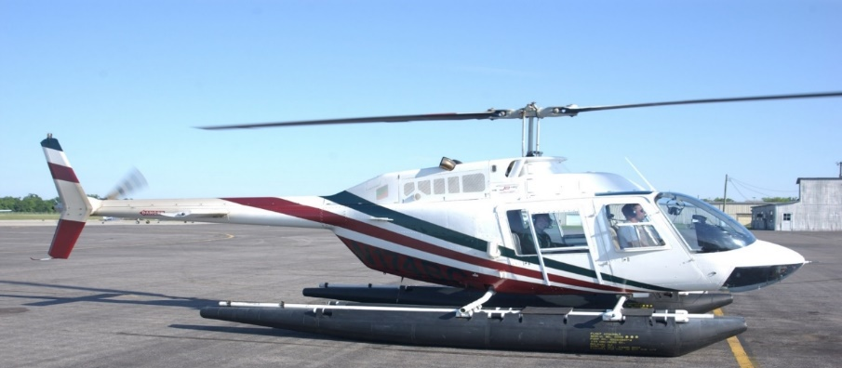

When vegetative damage was identified, the helicopter landed at the site and the following information was recorded:

1) Location of each site was determined by recording latitude and longitude utilizing GPS equipment. A real time differential corrected (WAAS Enabled) GPS (Garmin GPSmap 696) was utilized to allow for accurate location of damaged sites. The software GPSGate Splitter was used in conjunction with ArcView 10.2 run on a field laptop to determine the size of each damage site, by logging polygons using stream digitizing with the GPS equipment.

2) The abundance of nutria sign was placed in one of the following nutria relative abundance rating (NRAR) categories: (0) no nutria sign visible, (1) nutria sign visible, (2) abundant feeding, or (3) heavy feeding.

3) The extent of damage to the vegetation was placed in one of the following vegetative damage rating categories: (0) no vegetative damage; (1) minor vegetative damage which is defined as a site containing feeding holes, thinning vegetation and some visible soil; (2) moderate vegetative damage which is defined as a site that has large areas of exposed soil and covers less than 50% of the site; (3) severe vegetative damage which is defined as a site that has more than 50% of the soil exposed; or (4) converted to open water.

4) The dominant plant species were identified and recorded for damaged areas, recovering areas and in the adjacent areas.

5) The age of damage and condition is determined by considering feeding activity and vegetation condition. The age of damage and condition was placed in one of the following categories: (0) recovered, (1) old recovering, (2) old not recovering, (3) recent recovering, (4) recent not recovering, or (5) current (occurring now).

6) The prediction of vegetative recovery is made considering feeding activity, age of damage and the extent of damage. The prediction of vegetative recovery by the end of 2020 was characterized by one of the following categories: no recovery (0), full recovery (1), partial recovery (2) or increased damage (3).

7) The number of nutria observed at each site was recorded.

In addition to searching for new damaged sites, all previously identified damaged sites were revisited to assess extent and duration of damage or to characterize recovery. All data were entered into a computer for compilation. Damaged site locations are provided on the attached herbivory map and a data summary in Appendix B.

Results and Discussion

There were 25 nutria damage sites observed during the 2020 vegetative damage survey. The damage sites observed were the same 25 from the 2019 survey with no new sites recorded. Of the 25 sites, two were identified as recovered and the remaining 23 will be checked again in 2021 (Figure 8).

Figure 8. 2020 vegetation survey damage sites located along transect lines.

Nutria Damage
The following discussion details the 23 sites that had observable nutria damage during the 2020 survey (Appendix A). A total of 3,654 acres along transects, extrapolated to 13,702 acres coastwide were identified as impacted by nutria feeding activity. This represents approximately a 6.5% decrease in acres impacted by nutria since 2019 (3,907 acres, extrapolated 14,652 acres coastwide.) There were 7 damage sites documented during the 2019 survey that have since partially converted to open water with a total of 260 observed acres converted (Figure 12 and Tables 10A-10C). This conversion to open water accounts for much of the decrease in damaged acres from the previous year while two sites were marked as recovered for a total of 168 recovered acres.

Damage by Parish
Four parishes were observed to have damage in 2020. Most of the observed damaged acres were in Terrebonne Parish (3,456ac; 19 sites), followed by St. Mary Parish (110ac; 2 sites), Cameron Parish (39ac, 1 site), and St. Charles Parish (49ac, 1 site; Figure 9).

Figure 9. 2020 vegetation survey damaged acres by parish.

Damage by Marsh Type
Marsh type, based on Vegetation types as determined in coastal Louisiana in 2013 (Sasser, Visser, Mouton, Linscombe, and Hartley 2014), was recorded for each damage site (Figures 10A-10C).
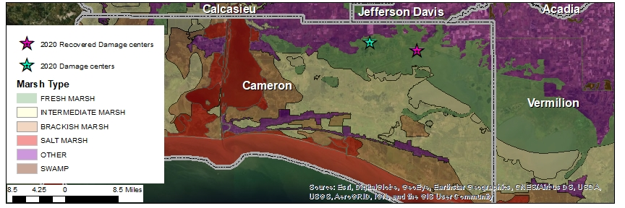
Figure 10 A. 2020 Vegetation survey damage centers. 1 damage site in Cameron Parish and one recovered.
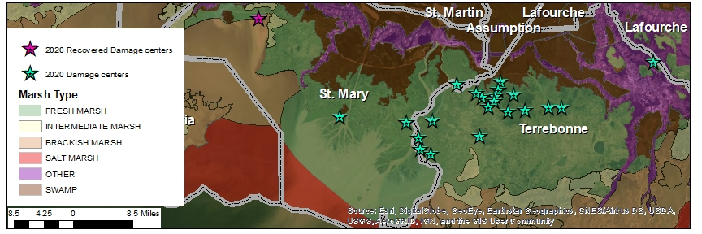
Figure 10 B. 2020 Vegetation survey damage centers. 2 sites in St. Mary and 19 sites in Terrebonne Parish.
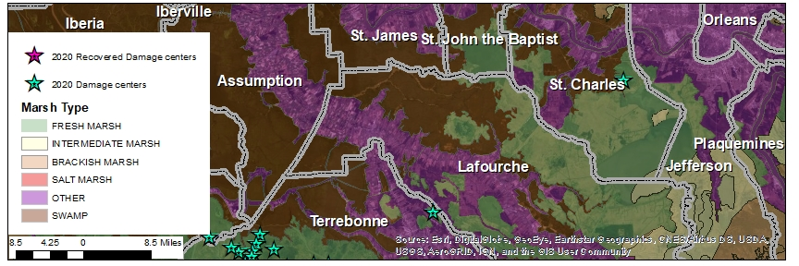
Figure 10 C. 2020 Vegetation survey damage centers. 1 site in St. Charles Parish. All observed sites damaged by nutria herbivory were located in fresh water marsh. The typical vegetation impacted in fresh marsh was Eleocharis spp., Hydrocotyle spp, and Bidens laevis.

Nutria Relative Abundance Rating
A nutria relative abundance rating (NRAR) was used to quantify the abundance of nutria at each site. Categories include: (0) no nutria sign visible, (1) nutria sign visible, (2) abundant feeding sign, and (3) heavy feeding sign; sites converted to open water are not given a NRAR (Figure 11.)

Figure 11. Nutria relative abundance ratings for 2020 nutria damaged sites. Includes the 168 acres of recovered sites.

Vegetative Damage Rating
Vegetative damage was also evaluated at each site. A rating system was developed to quantify nutria vegetative damage. The vegetative damage rating (VDR) has five categories: (0) no vegetative damage, (1) minor vegetative damage, (2) moderate vegetative damage, (3) severe vegetative damage, (4) converted to open water (Figure 12). Nine of the damage sites contained greater than one VDR as different portions of each site may be more or less damaged than other areas within the same site. The acres impacted is estimated from the proportion of each site impacted at each rating level.

Figure 12. Vegetative damage ratings for 2020 nutria damaged sites. Includes acres converted to open water and recovered acres.

Age of Damage Rating
Categories for the age of damage and condition rating include: (0) recovered, (1) old damage-recovering, (2) old damage not recovering, (3) recent damage-recovering, (4) recent damage-not recovering, and (5) current damage (Figure 13).

Figure 13. Age of damage and condition of 2020 nutria damaged sites. Includes recovered acres.

Prediction of Recovery
For each site with current damage, the degree of recovery by the end of the 2020 growing season was predicted. These categories include: (1) full recovery, (2) partial recovery, (3) increased damage and (4) no recovery predicted (Figure 14).

Figure 14. Prediction of recovery by the end of the growing season for the 2020 nutria damaged sites.

Conclusions

The 2020 vegetative damage survey yielded a total of 3,654 acres of nutria damage along transect lines. When extrapolated to the entire program area, an estimated 13,702 acres were impacted coastwide at the time of survey. When compared to the 2019 survey (3,907 acres, extrapolated to 14,652 acres coastwide), there was approximately a 6.5% decrease in the number of damaged acres. The decrease in damage is likely due to the acres converted to open water and to a smaller extent, the recovery of two sites. Due to circumstances out of our control, the survey was flown much later in the season than in typical years. By the time the survey was flown, the vegetation had had a longer amount of time to grow in which may have affected damage ratings at each site. Also, the warmer temperatures may have made visual observations of nutria in the marsh more difficult because individuals are more likely to be bedded down under cover during the day than out feeding.

Due to the distance between survey lines, all areas impacted by nutria herbivory could not be identified. Additionally, there were areas along survey lines where nutria activity was observed but marsh conditions did not warrant a damage classification (i.e., nutria present but no damage observed or damaged areas <1ac are too small to record). Only the most obvious impacted areas were detected and recorded so the total impact of nutria is likely underestimated.

Section 3

Summary of Results (2002-2020) and Adaptive Management

In total, 5,586,606 nutria have been harvested from coastal Louisiana through 18 seasons of the CNCP. Throughout much of the CNCP, seasonal nutria tail collection, which is how we determine harvest, has ranged between 300,000 and 400,000. From the beginning of the CNCP through 2011, estimated coastwide nutria damage declined nearly every year and then from 2011-2017, the damaged areas stabilized between 4,000 and 6,500 acres. Unfortunately, nutria harvest during the 2016-2017 and the 2017-2018 seasons was 216,059 and 170,471, respectively, which is substantially lower harvest than years prior. Subsequently, estimated coastwide nutria damage increased from 5,866 acres in 2017 to 16,424 acres in 2018. Harvest during the 2018-2019 season was higher (223,155) than the previous 2 seasons, but still lower than the average annual harvest which is 310,378 tails (Figure 15). Although the total damaged acres decreased from 16,424 in 2018 to 14,652 in 2019, the number of damage sites increased from 21 to 25 and approximately 910 acres were converted to open water. For the 2019-2020 season, the incentive payment was increased from $5.00 to $6.00. The increased payment had the desired affect with harvest increasing to 245,865.

Figure 15. Nutria harvest and coastwide nutria herbivory damage. The low harvest during the 2005-2006 season is attributed to the coastwide disruptions caused by Hurricane Katrina in August 2005.

Prior to implementation of CNCP incentive payments, nutria harvest was below 30,000 per season and coastwide nutria damage ranged between 79,000 and 98,000 acres (Table 2). Throughout 18 seasons of CNCP, nutria harvest has ranged from 168,843 to 445,963 (an average of 310,367) and coastwide nutria damage decreased to a range of 4,181 to 8,475 acres for 2010-2017, and has ranged from 13,703 to 16,424 acres in the last three years (Table 3).

Harvest Season | Nutria Harvested | Year of Survey | Herbivory Damage (acres)
1999-2000 | 20,110 | 2000 | 97,271
2000-2001 | 29,544 | 2001 | 83,021
2001-2002 | 24,683 | 2002 | 79,444
Table 2. Nutria harvest and herbivory damage in years prior to CNCP.

Harvest Season | Nutria Harvested | Total Incentive Payments | Year of Survey | Herbivory Damage (acres)
2002-2003 | 308,160 | $1,232,640 | 2003 | 82,080
2003-2004 | 332,596 | $1,330,384 | 2004 | 63,398
2004-2005 | 297,535 | $1,190,140 | 2005 | 53,475
2005-2006 | 168,843 | $675,372 | 2006 | 55,755
2006-2007 | 375,683 | $1,878,415 | 2007 | 34,665
2007-2008 | 308,212 | $1,541,060 | 2008 | 23,141
2008-2009 | 334,038 | $1,670,190 | 2009 | 20,333
2009-2010 | 445,963 | $2,229,815 | 2010 | 8,475
2010-2011 | 338,512 | $1,692,560 | 2011 | 6,296
2011-2012 | 354,354 | $1,771,770 | 2012 | 4,233
2012-2013 | 388,160 | $1,940,800 | 2013 | 4,624
2013-2014 | 388,264 | $1,941,320 | 2014 | 4,181
2014-2015 | 341,708 | $1,708,540 | 2015 | 6,008
2015-2016 | 349,235 | $1,746,175 | 2016 | 6,496
2016- 2017 | 216,052 | $1,080,260 | 2017 | 5,866
2017-2018 | 170,471 | $852,355 | 2018 | 16,424
2018-2019 | 223,155 | $1,115,775 | 2019 | 14,652
2019-2020 | 245,865 | $1,541,190 | 2020 | 13,702
Total | 5,586,606 | $28,244,895
Table 3. Nutria harvest and herbivory throughout 18 seasons of the CNCP.

Adaptive Management

The low nutria harvest throughout the 2016-2017, 2017-2018, and 2018-2019 seasons resulted in increased nutria damage throughout coastal Louisiana. Responses to participant surveys mailed during the summers of 2017 and 2018 indicated that raising the amount of the incentive payment would increase participation and nutria harvest. The increased payment did help increase harvest, but it is not the only factor that influences harvest. Other factors such as overall hunter participation, weather, and degradation of marsh habitat that may result in less land to take nutria or decreased access for hunters are also factors in total harvest. These latter factors are more difficult to mitigate and will continue to present a challenge for CNCP managers.

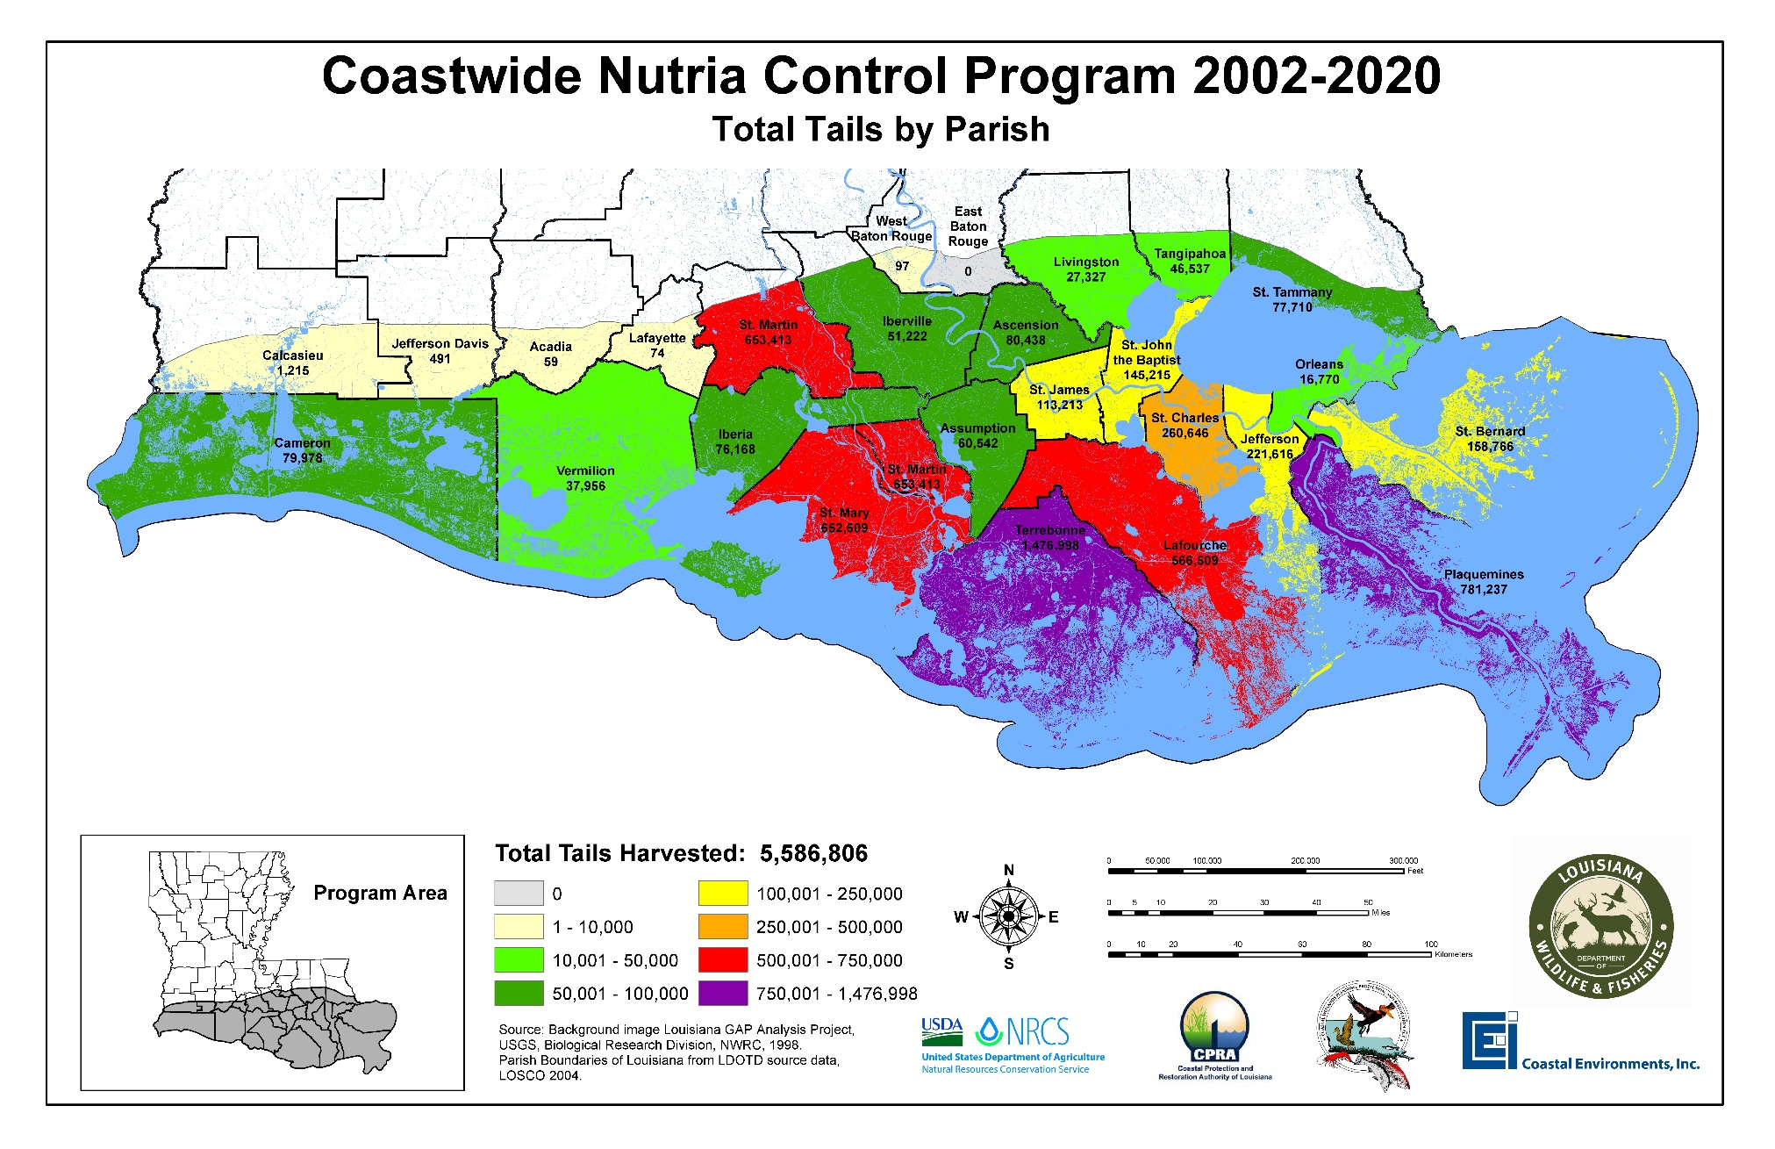
Figure 16. Total nutria harvest by Parish during 18 seasons of CNCP.
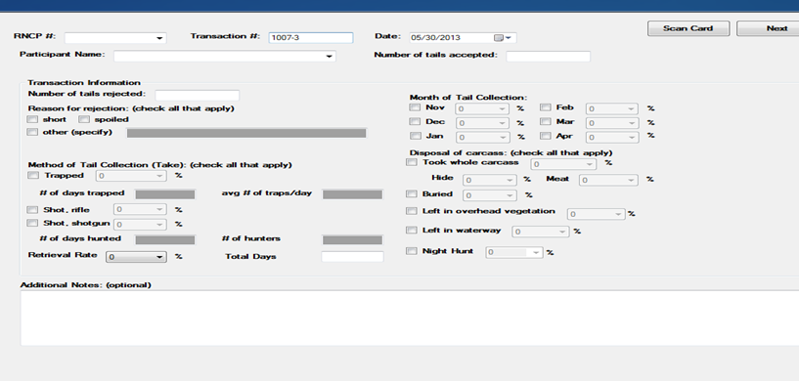
Figure 17. Screenshot of the digital datasheet used by Coastal Environments Inc. during the tail collections.

Appendix A.
A Comparison of Seasons 1-18
(2002-2020)

PARISH | 2002-2003 |  | 2003-2004 |  | 2004-2005 |  | 2005-2006 |  | 2006-2007 |  | 2007-2008
 | Nutria Harvested | Percentage | Nutria Harvested | Percentage | Nutria Harvested | Percentage | Nutria Harvested | Percentage | Nutria Harvested | Percentage | Nutria Harvested | Percentage
Acadia | 0 | - | 0 | - | 0 | - | 0 | - | 0 | - | 0 | -
Ascension | 2,710 | 0.88% | 5,474 | 1.65% | 1,855 | 0.62% | 1,678 | 0.99% | 2,226 | 0.59% | 1,957 | 0.63%
Assumption | 3,128 | 1.02% | 814 | 0.24% | 427 | 0.14% | 2,307 | 1.37% | 2,095 | 0.56% | 3,863 | 1.25%
Calcasieu | 143 | 0.05% | 374 | 0.11% | 447 | 0.15% | 58 | 0.03% | 19 | 0.01% | 19 | 0.01%
Cameron | 7,851 | 2.55% | 8,701 | 2.62% | 16,592 | 5.58% | 3,744 | 2.22% | 1,725 | 0.46% | 649 | 0.21%
East Baton Rouge | 0 | - | 0 | - | 0 | - | 0 | - | 0 | - | 0 | -
Iberia | 1,412 | 0.46% | 1,960 | 0.59% | 3,516 | 1.18% | 3,014 | 1.79% | 18,910 | 5.03% | 6,119 | 1.99%
Iberville | 0 | - | 1,567 | 0.47% | 5,551 | 1.87% | 2,360 | 1.40% | 9,172 | 2.44% | 2,105 | 0.68%
Jefferson | 20,529 | 6.66% | 24,896 | 7.49% | 11,019 | 3.70% | 2,875 | 1.70% | 10,405 | 2.77% | 11,299 | 3.67%
Jefferson Davis | 121 | 0.04% | 85 | 0.03% | 175 | 0.06% | 110 | 0.07% | 0 | - | 0 | -
Lafayette | 39 | 0.01% | 25 | 0.01% | 10 | 0.00% | 0 | - | 0 | - | 0 | -
Lafourche | 28,852 | 9.36% | 51,736 | 15.56% | 32,362 | 10.88% | 24,668 | 14.61% | 28,038 | 7.46% | 25,473 | 8.26%
Livingston | 2,631 | 0.85% | 357 | 0.11% | 910 | 0.31% | 1,921 | 1.14% | 1,250 | 0.33% | 695 | 0.23%
Orleans | 597 | 0.19% | 0 | - | 537 | 0.18% | 0 | - | 575 | 0.15% | 1,333 | 0.43%
Plaquemines | 63,208 | 20.51% | 86,720 | 26.07% | 38,984 | 13.10% | 1,816 | 1.08% | 5,815 | 1.55% | 41,072 | 13.33%
St. Bernard | 5,769 | 1.87% | 13,344 | 4.01% | 4,337 | 1.46% | 0 | - | 291 | 0.08% | 4,150 | 1.35%
St. Charles | 11,169 | 3.62% | 12,672 | 3.81% | 15,843 | 5.32% | 13,807 | 8.18% | 18,690 | 4.97% | 18,271 | 5.93%
St. James | 95 | 0.03% | 487 | 0.15% | 2,837 | 0.95% | 4,912 | 2.91% | 7,111 | 1.89% | 9,604 | 3.12%
St. John the Baptist | 18,450 | 5.99% | 6,137 | 1.85% | 8,391 | 2.82% | 6,384 | 3.78% | 15,786 | 4.20% | 6,728 | 2.18%
St. Martin | 11,425 | 3.71% | 15,039 | 4.52% | 31,608 | 10.62% | 15,903 | 9.42% | 113,629 | 30.25% | 54,726 | 17.76%
St. Mary | 26,004 | 8.44% | 16,277 | 4.89% | 20,908 | 7.03% | 21,023 | 12.45% | 34,693 | 9.23% | 34,210 | 11.10%
St. Tammany | 4,638 | 1.51% | 3,756 | 1.13% | 5,167 | 1.74% | 1,423 | 0.84% | 2,067 | 0.55% | 4,356 | 1.41%
Tangipahoa | 1,245 | 0.40% | 745 | 0.22% | 564 | 0.19% | 826 | 0.49% | 1,843 | 0.49% | 2,323 | 0.75%
Terrebonne | 92,831 | 30.12% | 72,846 | 21.90% | 81,012 | 27.23% | 57,756 | 34.21% | 99,433 | 26.47% | 78,934 | 25.61%
Vermilion | 5,313 | 1.72% | 8,584 | 2.58% | 14,481 | 4.87% | 2,258 | 1.34% | 1,813 | 0.48% | 326 | 0.11%
West Baton Rouge | 0 | - | 0 | - | 0 | - | 0 | - | 97 | 0.03% | 0 | -
Total | 308,160 | 1 | 332,596 | 1 | 297,535 | 1 | 168,843 | 1 | 375,683 | 1 | 308,212 | 1
Table 4. Nutria harvested by parish seasons 1-18, Coastwide Nutria Control Program.

PARISH | 2008-2009 |  | 2009-2010 |  | 2010-2011 |  | 2011-2012 |  | 2012-2013 |  | 2013-2014
 | Nutria Harvested | Percentage | Nutria Harvested | Percentage | Nutria Harvested | Percentage | Nutria Harvested | Percentage | Nutria Harvested | Percentage | Nutria Harvested | Percentage
Acadia | 0 | - | 0 | - | 0 | - | 0 | - | 59 | 0.02% | 0 | -
Ascension | 7,029 | 2.10% | 7,049 | 1.58% | 3,435 | 1.01% | 0 | - | 0 | - | 7,889 | 2.03%
Assumption | 1,093 | 0.33% | 2,930 | 0.66% | 3,244 | 0.96% | 3,582 | 1.01% | 6,302 | 1.62% | 7,904 | 2.04%
Calcasieu | 0 | - | 0 | - | 0 | - | 0 | - | 0 | - | 0 | -
Cameron | 1,245 | 0.37% | 1,177 | 0.26% | 1,076 | 0.32% | 413 | 0.12% | 174 | 0.04% | 1,446 | 0.37%
East Baton Rouge | 0 | - | 0 | - | 0 | - | 0 | - | 0 | - | 0 | -
Iberia | 978 | 0.29% | 1,206 | 0.27% | 286 | 0.08% | 1,384 | 0.39% | 5,360 | 1.38% | 12,157 | 3.13%
Iberville | 231 | 0.07% | 6,065 | 1.36% | 886 | 0.26% | 1,688 | 0.48% | 3,062 | 0.79% | 3,046 | 0.78%
Jefferson | 12,515 | 3.75% | 11,506 | 2.58% | 5,945 | 1.76% | 6,178 | 1.74% | 16,152 | 4.16% | 10,244 | 2.64%
Jefferson Davis | 0 | - | 0 | - | 0 | - | 0 | - | 0 | - | 0 | -
Lafayette | 0 | - | 0 | - | 0 | - | 0 | - | 0 | - | 0 | -
Lafourche | 48,252 | 14.45% | 39,564 | 8.87% | 37,137 | 10.97% | 37,415 | 10.56% | 47,723 | 12.29% | 42,061 | 10.83%
Livingston | 444 | 0.13% | 2,186 | 0.49% | 738 | 0.22% | 0 | - | 0 | - | 3,405 | 0.88%
Orleans | 656 | 0.20% | 1,756 | 0.39% | 2,279 | 0.67% | 1,238 | 0.35% | 1,006 | 0.26% | 929 | 0.24%
Plaquemines | 42,212 | 12.64% | 69,294 | 15.54% | 80,241 | 23.70% | 71,879 | 20.28% | 22,171 | 5.71% | 21,808 | 5.62%
St. Bernard | 13,965 | 4.18% | 3,543 | 0.79% | 29,278 | 8.65% | 27,053 | 7.63% | 4,073 | 1.05% | 5,201 | 1.34%
St. Charles | 21,215 | 6.35% | 27,221 | 6.10% | 16,069 | 4.75% | 10,830 | 3.06% | 14,347 | 3.70% | 14,164 | 3.65%
St. James | 8,990 | 2.69% | 19,226 | 4.31% | 9,167 | 2.71% | 15,450 | 4.36% | 14,455 | 3.72% | 5,443 | 1.40%
St. John the Baptist | 10,189 | 3.05% | 6,642 | 1.49% | 9,447 | 2.79% | 2,678 | 0.76% | 6,832 | 1.76% | 3,237 | 0.83%
St. Martin | 44,972 | 13.46% | 63,619 | 14.27% | 23,551 | 6.96% | 36,562 | 10.32% | 40,356 | 10.40% | 54,027 | 13.92%
St. Mary | 34,811 | 10.42% | 67,631 | 15.17% | 43,533 | 12.86% | 45,859 | 12.94% | 64,386 | 16.59% | 58,229 | 15.00%
St. Tammany | 5,680 | 1.70% | 8,855 | 1.99% | 6,562 | 1.94% | 6,417 | 1.81% | 1,217 | 0.31% | 1,485 | 0.38%
Tangipahoa | 4,974 | 1.49% | 267 | 0.06% | 448 | 0.13% | 141 | 0.04% | 1,864 | 0.48% | 4,637 | 1.19%
Terrebonne | 74,587 | 22.33% | 106,226 | 23.82% | 65,190 | 19.26% | 85,587 | 24.15% | 138,305 | 35.63% | 130,952 | 33.73%
Vermilion | 0 | - | 0 | - | 0 | - | 0 | - | 316 | 0.08% | 0 | -
West Baton Rouge | 0 | - | 0 | - | 0 | - | 0 | - | 0 | - | 0 | -
Total | 334,038 | 1 | 445,963 | 1 | 338,512 | 1 | 354,354 | 1 | 388,160 | 1 | 388,264 | 1
Table 4 (Continued). Nutria harvested by parish seasons 1-18, Coastwide Nutria Control Program.

PARISH | 2014-2015 |  | 2015-2016 |  | 2016-2017 |  | 2017-2018 |  | 2018-2019 |  | 2019-2020
 | Nutria Harvested | Percentage | Nutria Harvested | Percentage | Nutria Harvested | Percentage | Nutria Harvested | Percentage | Nutria Harvested | Percentage | Nutria Harvested | Percentage
Acadia | 0 | - | 0 | - | 0 | - | 0 | - | 0 | - | 0 | -
Ascension | 16,013 | 4.69% | 4,693 | 1.34% | 1,777 | 0.82% | 1,353 | 0.79% | 1,537 | 0.90% | 2,245 | 0.91%
Assumption | 7,603 | 2.22% | 3,096 | 0.89% | 2,372 | 1.10% | 1,555 | 0.91% | 1,886 | 1.11% | 927 | 0.38%
Calcasieu | 0 | - | 0 | - | 0 | - | 154 | 0.09% | 0 | - | 0 | 0.00%
Cameron | 2,848 | 0.83% | 2,607 | 0.75% | 2,534 | 1.17% | 5,805 | 3.41% | 13,835 | 8.12% | 7,531 | 3.06%
East Baton Rouge | 0 | - | 0 | - | 0 | - | 0 | - | 0 | - | 0 | -
Iberia | 7,296 | 2.14% | 4,516 | 1.29% | 2,514 | 1.16% | 1,683 | 0.99% | 2,469 | 1.45% | 1,761 | 0.72%
Iberville | 1,076 | 0.31% | 2,930 | 0.84% | 419 | 0.19% | 2,379 | 1.40% | 4,122 | 2.42% | 6,350 | 2.58%
Jefferson | 12,855 | 3.76% | 12,239 | 3.50% | 20,025 | 9.27% | 11,060 | 6.49% | 13,695 | 8.03% | 8,277 | 3.37%
Jefferson Davis | 0 | - | 0 | - | 0 | - | 0 | - | 0 | - | 0 | -
Lafayette | 0 | - | 0 | - | 0 | - | 0 | - | 0 | - | 0 | -
Lafourche | 29,190 | 8.54% | 31,810 | 9.11% | 18,249 | 8.45% | 10,388 | 6.09% | 19,458 | 11.41% | 14,418 | 5.86%
Livingston | 1,279 | 0.37% | 0 | 0.00% | 1,879 | 0.87% | 1,538 | 0.90% | 2,539 | 1.49% | 4,281 | 1.74%
Orleans | 485 | 0.14% | 1,103 | 0.32% | 1,077 | 0.50% | 334 | 0.20% | 163 | 0.10% | 2,702 | 1.10%
Plaquemines | 23,883 | 6.99% | 46,672 | 13.36% | 33,684 | 15.59% | 29,474 | 17.29% | 39,657 | 23.26% | 62,380 | 25.37%
St. Bernard | 5,410 | 1.58% | 12,939 | 3.70% | 11,094 | 5.13% | 3,533 | 2.07% | 3,729 | 2.19% | 11,141 | 4.53%
St. Charles | 16,355 | 4.79% | 13,685 | 3.92% | 11,602 | 5.37% | 5,626 | 3.30% | 7,350 | 4.31% | 11,707 | 4.76%
St. James | 769 | 0.23% | 7,651 | 2.19% | 3,005 | 1.39% | 2,226 | 1.31% | 2,600 | 1.52% | 3,646 | 1.48%
St. John the Baptist | 3,394 | 0.99% | 18,412 | 5.27% | 6,351 | 2.94% | 6,416 | 3.76% | 5,717 | 3.35% | 12,334 | 5.02%
St. Martin | 50,392 | 14.75% | 50,202 | 14.37% | 9,838 | 4.55% | 14,746 | 8.65% | 13,263 | 7.78% | 9,991 | 4.06%
St. Mary | 40,045 | 11.72% | 28,585 | 8.19% | 32,102 | 14.86% | 26,869 | 15.76% | 31,257 | 18.34% | 27,963 | 11.37%
St. Tammany | 1,481 | 0.43% | 9,562 | 2.74% | 5,244 | 2.43% | 2,020 | 1.18% | 2,331 | 1.37% | 5,442 | 2.21%
Tangipahoa | 6,758 | 1.98% | 4,894 | 1.40% | 2,998 | 1.39% | 1,331 | 0.78% | 3,387 | 1.99% | 7,290 | 2.97%
Terrebonne | 114,373 | 33.47% | 93,301 | 26.72% | 48,411 | 22.41% | 40,581 | 23.81% | 51,960 | 30.48% | 45,208 | 18.39%
Vermilion | 203 | 0.06% | 341 | 0.10% | 877 | 0.41% | 1,400 | 0.82% | 2,201 | 1.29% | 271 | 0.11%
West Baton Rouge | 0 | - | 0 | - | 0 | - | 0 | - | 0 | - | 0 | -
Total | 341,708 | 1 | 349,235 | 1 | 216,052 | 1 | 170,471 | 1 | 223,155 | 1 | 245,865 | 1
Table 4 (Continued). Nutria harvested by parish seasons 1-18, Coastwide Nutria Control Program.

PARISH | 2002-2003 |  |  | 2003-2004 |  |  | 2004-2005 |  |  | 2005-2006
 | Trap | Rifle | Shotgun | Trap | Rifle | Shotgun | Trap | Rifle | Shotgun | Trap | Rifle | Shotgun
Acadia | 0 | 0 | 0 | 0 | 0 | 0 | 0 | 0 | 0 | 0 | 0 | 0
Ascension | 0 | 2,306 | 404 | 0 | 4,093 | 1,381 | 100 | 1,678 | 80 | 470 | 908 | 300
Assumption | 284 | 2,786 | 58 | 47 | 767 | 0 | 188 | 106 | 134 | 1,454 | 711 | 143
Calcasieu | 0 | 143 | 0 | 0 | 374 | 0 | 213 | 24 | 212 | 57 | 1 | 0
Cameron | 3,611 | 4,210 | 30 | 4,974 | 3,639 | 89 | 5,779 | 8,961 | 1,877 | 1,362 | 583 | 1,799
Iberia | 0 | 1,353 | 59 | 636 | 1,324 | 0 | 1,286 | 1,310 | 926 | 1,215 | 449 | 1,350
Iberville | 0 | 0 | 0 | 717 | 850 | 0 | 4,348 | 1,211 | 0 | 1,156 | 622 | 582
Jefferson | 5,869 | 14,094 | 566 | 12,991 | 11,835 | 70 | 6,286 | 4,307 | 443 | 2,234 | 477 | 164
Jefferson Davis | 121 | 0 | 0 | 82 | 0 | 0 | 158 | 16 | 0 | 109 | 1 | 0
Lafayette | 19 | 10 | 10 | 0 | 25 | 0 | 0 | 10 | 0 | 0 | 0 | 0
Lafourche | 11,807 | 16,826 | 219 | 28,516 | 22,780 | 440 | 12,221 | 18,212 | 1,977 | 9,213 | 11,050 | 4,598
Livingston | 0 | 2,631 | 0 | 0 | 336 | 21 | 0 | 911 | 0 | 0 | 1,921 | 0
Orleans | 287 | 219 | 91 | 0 | 0 | 0 | 538 | 0 | 0 | 0 | 0 | 0
Plaquemines | 9,899 | 52,933 | 376 | 34,683 | 51,302 | 735 | 18,121 | 20,642 | 280 | 343 | 843 | 630
St. Bernard | 2,877 | 2,892 | 0 | 5,412 | 7,783 | 149 | 727 | 3,617 | 0 | 0 | 0 | 0
St. Charles | 2,099 | 8,706 | 364 | 2,801 | 9,543 | 329 | 1,279 | 13,958 | 631 | 1,863 | 10,915 | 1,029
St. James | 48 | 47 | 0 | 97 | 350 | 40 | 32 | 2,752 | 57 | 278 | 4,239 | 395
St. John the Baptist | 1,505 | 11,132 | 5,813 | 2,517 | 2,200 | 1,420 | 2,971 | 4,788 | 645 | 2,165 | 3,488 | 538
St. Martin | 1,497 | 9,593 | 335 | 5,784 | 8,790 | 465 | 10,684 | 9,703 | 11,269 | 4,137 | 5,355 | 6,412
St. Mary | 11,073 | 14,849 | 82 | 6,616 | 9,619 | 42 | 9,700 | 10,798 | 442 | 9,266 | 11,202 | 554
St. Tammany | 3,088 | 1,529 | 21 | 2,687 | 1,069 | 0 | 2,692 | 2,483 | 0 | 533 | 800 | 90
Tangipahoa | 335 | 894 | 16 | 577 | 169 | 0 | 35 | 530 | 0 | 142 | 638 | 46
Terrebonne | 46,761 | 45,317 | 753 | 44,419 | 26,335 | 2,092 | 31,730 | 45,893 | 3,512 | 28,132 | 25,577 | 4,047
Vermilion | 2,370 | 2,729 | 214 | 5,119 | 3,435 | 30 | 5,580 | 7,900 | 572 | 1,075 | 1,182 | 0
West Baton Rouge | 0 | 0 | 0 | 0 | 0 | 0 | 0 | 0 | 0 | 0 | 0 | 0
Total | 103,550 | 195,199 | 9,411 | 158,675 | 166,618 | 7,303 | 114,668 | 159,810 | 23,057 | 65,204 | 80,962 | 22,677
Table 5. Method of take by parish for seasons 1-18, Coastwide Nutria Control Program. Totals may not be exact due to reporting of percentages.

PARISH | 2006-2007 |  |  | 2007-2008 |  |  | 2008-2009 |  |  | 2009-2010
 | Trap | Rifle | Shotgun | Trap | Rifle | Shotgun | Trap | Rifle | Shotgun | Trap | Rifle | Shotgun
Acadia | 0 | 0 | 0 | 0 | 0 | 0 | 0 | 0 | 0 | 0 | 0 | 0
Ascension | 0 | 2,008 | 218 | 0 | 1,905 | 52 | 217 | 6,751 | 61 | 338 | 6,712 | 0
Assumption | 354 | 686 | 1,056 | 634 | 2,944 | 285 | 85 | 933 | 75 | 546 | 1,916 | 469
Calcasieu | 19 | 0 | 0 | 19 | 0 | 0 | 0 | 0 | 0 | 0 | 0 | 0
Cameron | 347 | 902 | 477 | 509 | 70 | 70 | 1,060 | 128 | 55 | 1,174 | 0 | 0
Iberia | 6,695 | 4,635 | 7,580 | 3,623 | 1,248 | 1,247 | 258 | 524 | 196 | 932 | 274 | 0
Iberville | 4,907 | 460 | 3,860 | 754 | 508 | 843 | 103 | 0 | 128 | 4,051 | 1,670 | 344
Jefferson | 4,731 | 5,568 | 106 | 3,901 | 6,456 | 943 | 4,185 | 8,146 | 184 | 3,164 | 8,202 | 140
Jefferson Davis | 0 | 0 | 0 | 0 | 0 | 0 | 0 | 0 | 0 | 0 | 0 | 0
Lafayette | 0 | 0 | 0 | 0 | 0 | 0 | 0 | 0 | 0 | 0 | 0 | 0
Lafourche | 12,260 | 11,460 | 4,259 | 9,701 | 11,425 | 4,345 | 32,373 | 13,324 | 2,555 | 21,796 | 16,310 | 1,458
Livingston | 0 | 1,250 | 0 | 0 | 695 | 0 | 0 | 444 | 0 | 460 | 1,726 | 0
Orleans | 575 | 0 | 0 | 1,333 | 0 | 0 | 656 | 0 | 0 | 1,658 | 71 | 27
Plaquemines | 3,200 | 2,554 | 61 | 30,093 | 10,609 | 0 | 21,394 | 19,372 | 1,447 | 25,379 | 43,480 | 436
St. Bernard | 146 | 146 | 0 | 4,071 | 79 | 370 | 9,790 | 4,131 | 43 | 3,177 | 240 | 126
St. Charles | 6,637 | 9,401 | 2,652 | 3,607 | 13,366 | 1,298 | 6,111 | 14,036 | 1,068 | 7,712 | 18,593 | 916
St. James | 203 | 6,439 | 469 | 425 | 9,128 | 51 | 597 | 7,862 | 531 | 572 | 17,805 | 849
St. John the Baptist | 4,223 | 9,215 | 2,348 | 2,323 | 3,834 | 572 | 1,490 | 8,372 | 327 | 2,856 | 3,776 | 10
St. Martin | 39,972 | 35,737 | 37,920 | 27,937 | 17,123 | 9,666 | 21,134 | 17,512 | 6,326 | 43,341 | 12,952 | 7,326
St. Mary | 12,810 | 19,997 | 1,886 | 10,783 | 21,304 | 2,123 | 13,357 | 18,480 | 2,974 | 13,026 | 51,170 | 3,435
St. Tammany | 1,452 | 529 | 86 | 1,736 | 2,216 | 404 | 3,377 | 1,848 | 456 | 2,604 | 4,945 | 1,307
Tangipahoa | 542 | 1,189 | 113 | 563 | 1,760 | 0 | 321 | 4,530 | 124 | 0 | 267 | 0
Terrebonne | 36,867 | 51,357 | 11,209 | 28,055 | 45,000 | 5,879 | 25,846 | 46,139 | 2,602 | 40,669 | 62,264 | 3,292
Vermilion | 1,174 | 494 | 145 | 262 | 65 | 0 | 0 | 0 | 0 | 0 | 0 | 0
West Baton Rouge | 0 | 97 | 0 | 0 | 0 | 0 | 0 | 0 | 0 | 0 | 0 | 0
Total | 137,114 | 164,124 | 74,445 | 130,329 | 149,735 | 28,148 | 142,354 | 172,532 | 19,152 | 173,455 | 252,373 | 20,135
Table 5 (continued). Method of take by parish for seasons 1-18, Coastwide Nutria Control Program. Totals may not be exact due to reporting of percentages.

PARISH | 2010-2011 |  |  | 2011-2012 |  |  | 2012-2013 |  |  | 2013-2014
 | Trap | Rifle | Shotgun | Trap | Rifle | Shotgun | Trap | Rifle | Shotgun | Trap | Rifle | Shotgun
Acadia | 0 | 0 | 0 | 0 | 0 | 0 | 18 | 41 | 0 | 0 | 0 | 0
Ascension | 0 | 3,107 | 0 | 0 | 0 | 0 | 0 | 0 | 0 | 368 | 7,482 | 39
Assumption | 327 | 2,520 | 407 | 1,003 | 2,449 | 129 | 1,249 | 4,844 | 210 | 2,113 | 5,251 | 539
Calcasieu | 315 | 0 | 0 | 0 | 0 | 0 | 0 | 0 | 0 | 0 | 0 | 0
Cameron | 0 | 72 | 0 | 413 | 0 | 0 | 174 | 0 | 0 | 1,446 | 0 | 0
Iberia | 1,103 | 46 | 89 | 222 | 1,163 | 0 | 1,602 | 2,862 | 896 | 5,579 | 5,906 | 671
Iberville | 150 | 348 | 42 | 404 | 727 | 558 | 1,014 | 1,680 | 368 | 1,546 | 1,368 | 132
Jefferson | 494 | 4,059 | 109 | 1,655 | 4,496 | 27 | 2,630 | 11,349 | 2,173 | 2,389 | 7,796 | 59
Jefferson Davis | 1,872 | 0 | 0 | 0 | 0 | 0 | 0 | 0 | 0 | 0 | 0 | 0
Lafayette | 0 | 0 | 0 | 0 | 0 | 0 | 0 | 0 | 0 | 0 | 0 | 0
Lafourche | 0 | 23,326 | 43 | 9,573 | 27,574 | 267 | 11,260 | 33,137 | 3,326 | 9,924 | 31,266 | 870
Livingston | 13,713 | 738 | 0 | 0 | 0 | 0 | 0 | 0 | 0 | 985 | 2,420 | 0
Orleans | 0 | 115 | 0 | 1,202 | 36 | 0 | 1,006 | 0 | 0 | 929 | 0 | 0
Plaquemines | 2,162 | 67,649 | 557 | 25,139 | 46,498 | 241 | 8,347 | 13,641 | 182 | 6,265 | 15,449 | 95
St. Bernard | 12,021 | 11,489 | 12 | 16,226 | 10,826 | 0 | 1,214 | 1,276 | 1,584 | 3,228 | 1,974 | 0
St. Charles | 17,764 | 10,155 | 671 | 2,425 | 8,240 | 165 | 2,473 | 9,748 | 2,125 | 3,806 | 9,587 | 771
St. James | 5,225 | 9,016 | 115 | 0 | 15,417 | 33 | 157 | 13,199 | 1,099 | 32 | 5,410 | 0
St. John the Baptist | 35 | 5,922 | 327 | 1,366 | 1,312 | 0 | 397 | 6,401 | 35 | 510 | 2,645 | 82
St. Martin | 3,191 | 11,902 | 1,548 | 11,596 | 17,696 | 7,269 | 12,270 | 19,881 | 8,205 | 15,574 | 33,631 | 4,822
St. Mary | 10,115 | 36,334 | 246 | 7,450 | 36,295 | 2,113 | 13,393 | 44,951 | 6,042 | 6,503 | 46,810 | 4,917
St. Tammany | 6,928 | 2,947 | 899 | 4,817 | 1,123 | 477 | 579 | 588 | 50 | 1,312 | 174 | 0
Tangipahoa | 2,711 | 398 | 0 | 0 | 142 | 0 | 0 | 1,205 | 659 | 2,211 | 2,426 | 0
Terrebonne | 50 | 31,676 | 8,499 | 32,570 | 45,238 | 7,782 | 57,953 | 64,349 | 16,002 | 39,868 | 82,356 | 8,728
Vermilion | 24,953 | 0 | 0 | 0 | 0 | 0 | 130 | 186 | 0 | 0 | 0 | 0
West Baton Rouge | 0 | 0 | 0 | 0 | 0 | 0 | 0 | 0 | 0 | 0 | 0 | 0
Total | 103,129 | 221,819 | 13,564 | 116,061 | 219,232 | 19,061 | 115,866 | 229,338 | 42,956 | 104,588 | 261,951 | 21,725
Table 5 (continued). Method of take by parish for seasons 1-18, Coastwide Nutria Control Program. Totals may not be exact due to reporting of percentages.

PARISH | 2014-2015 |  |  | 2015-2016 |  |  | 2016-2017 |  |  | 2017-2018
 | Trap | Rifle | Shotgun | Trap | Rifle | Shotgun | Trap | Rifle | Shotgun | Trap | Rifle | Shotgun
Acadia | 0 | 0 | 0 | 0 | 0 | 0 | 0 | 0 | 0 | 0 | 0 | 0
Ascension | 551 | 15,259 | 202 | 257 | 4,226 | 209 | 159 | 1,505 | 112 | 184 | 947 | 221
Assumption | 1,088 | 5,555 | 959 | 1,263 | 1,117 | 716 | 41 | 1,996 | 335 | 1,107 | 281 | 167
Calcasieu | 0 | 0 | 0 | 0 | 0 | 0 | 0 | 0 | 0 | 118 | 0 | 36
Cameron | 2,848 | 0 | 0 | 2,607 | 0 | 0 | 2,310 | 224 | 0 | 5,008 | 545 | 252
Iberia | 3,464 | 3,148 | 684 | 1,321 | 2,854 | 341 | 60 | 1,394 | 1,060 | 427 | 656 | 599
Iberville | 229 | 809 | 39 | 0 | 2,420 | 510 | 63 | 136 | 220 | 1,297 | 783 | 299
Jefferson | 2,913 | 9,481 | 462 | 3,228 | 8,590 | 421 | 5,188 | 11,403 | 3,435 | 2,581 | 7,464 | 1,015
Jefferson Davis | 0 | 0 | 0 | 0 | 0 | 0 | 0 | 0 | 0 | 0 | 0 | 0
Lafayette | 0 | 0 | 0 | 0 | 0 | 0 | 0 | 0 | 0 | 0 | 0 | 0
Lafourche | 7,737 | 21,453 | 0 | 7,820 | 23,783 | 207 | 6,352 | 11,177 | 720 | 4,115 | 6,145 | 128
Livingston | 0 | 1,279 | 0 | 0 | 0 | 0 | 192 | 1,587 | 99 | 194 | 1,106 | 238
Orleans | 485 | 0 | 0 | 1,045 | 58 | 0 | 1,077 | 0 | 0 | 283 | 50 | 0
Plaquemines | 6,570 | 17,193 | 120 | 12,362 | 33,110 | 1,200 | 6,052 | 25,136 | 2,496 | 4,518 | 20,482 | 4,474
St. Bernard | 4,346 | 1,064 | 0 | 7,828 | 4,995 | 116 | 7,028 | 3,892 | 175 | 1,825 | 1,580 | 128
St. Charles | 3,592 | 12,659 | 104 | 2,682 | 9,047 | 1,956 | 4,772 | 6,205 | 626 | 774 | 3,844 | 1,008
St. James | 133 | 635 | 0 | 790 | 6,059 | 802 | 264 | 2,550 | 191 | 303 | 1,563 | 361
St. John the Baptist | 1,055 | 2,226 | 113 | 3,794 | 13,511 | 1,107 | 1,043 | 5,280 | 28 | 1,274 | 3,880 | 1,263
St. Martin | 20,118 | 25,891 | 4,384 | 23,973 | 22,706 | 3,523 | 5,562 | 2,002 | 2,274 | 4,196 | 5,405 | 5,145
St. Mary | 6,003 | 29,024 | 5,019 | 1,363 | 24,494 | 2,729 | 6,029 | 20,622 | 5,450 | 6,618 | 17,099 | 3,152
St. Tammany | 1,282 | 69 | 131 | 726 | 8,229 | 607 | 1,142 | 1,092 | 3,010 | 1,092 | 928 | 0
Tangipahoa | 28 | 6,731 | 0 | 23 | 4,870 | 0 | 784 | 2,185 | 29 | 238 | 955 | 138
Terrebonne | 36,381 | 65,519 | 12,471 | 21,032 | 57,978 | 14,291 | 12,517 | 25,830 | 10,064 | 10,134 | 23,602 | 6,846
Vermilion | 101 | 101 | 0 | 73 | 268 | 0 | 159 | 718 | 0 | 134 | 1,241 | 26
West Baton Rouge | 0 | 0 | 0 | 0 | 0 | 0 | 0 | 0 | 0 | 0 | 0 | 0
Total | 98,924 | 218,096 | 24,688 | 92,186 | 228,316 | 28,733 | 60,794 | 124,934 | 30,324 | 46,421 | 98,555 | 25,495
Table 5 (continued). Method of take by parish for seasons 1-18, Coastwide Nutria Control Program. Totals may not be exact due to reporting of percentages.

PARISH | 2018-2019 |  |  | 2019-2020
 | Trap | Rifle | Shotgun | Trap | Rifle | Shotgun
Acadia | 0 | 0 | 0 | 0 | 0 | 0
Ascension | 274 | 1,234 | 29 | 638 | 1539 | 68
Assumption | 644 | 1,143 | 98 | 113 | 716 | 98
Calcasieu | 0 | 0 | 0 | 0 | 0 | 0
Cameron | 13,314 | 521 | 0 | 6956 | 509 | 66
Iberia | 518 | 1,187 | 765 | 334 | 1391 | 36
Iberville | 1,077 | 2,545 | 501 | 693 | 5325 | 332
Jefferson | 4,650 | 6,236 | 2,809 | 3574 | 4514 | 189
Jefferson Davis | 0 | 0 | 0 | 0 | 0 | 0
Lafayette | 0 | 0 | 0 | 0 | 0 | 0
Lafourche | 7,575 | 11,329 | 553 | 3504 | 10519 | 395
Livingston | 536 | 1,959 | 43 | 1088 | 3028 | 165
Orleans | 75 | 88 | 0 | 0 | 2702 | 0
Plaquemines | 4,846 | 24,351 | 10,460 | 1784 | 39530 | 21066
St. Bernard | 767 | 2,789 | 173 | 2909 | 7221 | 1012
St. Charles | 2,283 | 4,972 | 95 | 3603 | 7867 | 238
St. James | 454 | 2,112 | 33 | 1035 | 2500 | 111
St. John the Baptist | 1,486 | 4,231 | 0 | 1896 | 9191 | 1247
St. Martin | 5,833 | 3,442 | 3,987 | 3060 | 5147 | 1784
St. Mary | 6,345 | 20,505 | 4,406 | 5435 | 19437 | 3091
St. Tammany | 1,059 | 1,187 | 85 | 116 | 2777 | 2549
Tangipahoa | 1,078 | 1,942 | 367 | 1497 | 5230 | 563
Terrebonne | 6,777 | 30,073 | 15,110 | 9458 | 21974 | 13776
Vermilion | 415 | 1,578 | 209 | 23 | 248 | 0
West Baton Rouge | 0 | 0 | 0 | 0 | 0 | 0
Total | 60,006 | 123,426 | 39,723 | 47,715 | 151,365 | 46,785
Table 5 (continued). Method of take by parish for seasons 1-18, Coastwide Nutria Control Program. Totals may not be exact due to reporting of percentages.

Year | Number of Sites Surveyed | Number of Sites with Current Damage | Number of Sites Converted to Open Water | Sites with Vegetative Recovery
2002 | 108¹ | 86 | 8 | 12
2003 | 100 | 81 | 3 | 16
2004 | 93 | 68 | 1 | 24
2005 | 78 | 47 | 2 | 29
2006 | 52 | 31 | 9 | 12
2007 | 34 | 23 | 3 (partial sites) | 11²
2008 | 23 | 16 | 1 (partial site) | 6
2009 | 24 | 19 | 1 (partial site) | 5²
2010 | 20 | 11 | 0 | 9
2011 | 11 | 10 | 0 | 1
2012 | 12 | 11 | 0 | 1
2013 | 14 | 12 | 0 | 2
2014 | 13 | 11 | 0 | 2
2015 | 12 | 11 | 0 | 1
2016 | 10 | 10 | 4 (partial sites) | 0
2017 | 17 | 16 | 5 (partial sites) | 1
2018 | 25^{1,3} | 21 | 6 (partial sites) | 2
2019 | 25 | 25 | 11 (partial sites) | 0
2020 | 25 | 23 | 7 (partial sites) | 2
Table 6. Status and number of nutria herbivory sites surveyed from 2002 to 2020.
¹ Two sites could not be evaluated due to high water.
² Total includes 1 site with partial recovery.
³ Two separate sites from previous season merged together to form single site

PARISH | 2002 |  | 2003 |  | 2004 |  | 2005 |  | 2006
 | NUMBER OF |  | NUMBER OF |  | NUMBER OF |  | NUMBER OF |  | NUMBER OF
 | SITES | ACRES | SITES | ACRES | SITES | ACRES | SITES | ACRES | SITES | ACRES
Terrebonne | 41 | 12,951 | 34 | 12,521 | 27 | 7,679 | 18 | 4,541 | 14 | 7,340
Lafourche | 8 | 1,222 | 7 | 610 | 5 | 381 | 2 | 127 | 0 | 0
Jefferson | 17 | 3,003 | 10 | 1,805 | 9 | 1,718 | 7 | 1,383 | 5 | 874
Plaquemines | 10 | 882 | 13 | 2,540 | 7 | 2,494 | 7 | 1,850 | 7 | 1763
St. Charles | 6 | 768 | 6 | 1,266 | 9 | 2,564 | 6 | 4,690 | 5 | 3249
Cameron | 0 | 0 | 0 | 0 | 0 | 0 | 0 | 0 | 1 | 233
St. Bernard | 6 | 921 | 5 | 918 | 5 | 1,035 | 4 | 882 | 4 | 1,004
St. John | 0 | 0 | 1 | 20 | 2 | 111 | 2 | 240 | 2 | 241
Iberia | 0 | 0 | 0 | 0 | 0 | 0 | 1 | 158 | 0 | 0
St. Tammany | 4 | 752 | 2 | 360 | 0 | 0 | 0 | 0 | 0 | 0
Orleans | 2 | 686 | 2 | 962 | 0 | 0 | 0 | 0 | 0 | 0
St. Mary | 0 | 0 | 0 | 0 | 0 | 0 | 0 | 0 | 0 | 0
Vermilion | 0 | 0 | 4 | 886 | 5 | 924 | 2 | 389 | 1 | 76
Jefferson Davis | 0 | 0 | 0 | 0 | 0 | 0 | 0 | 0 | 1 | 88
St. John the Baptist | 0 | 0 | 0 | 0 | 0 | 0 | 0 | 0 | 0 | 0
Total | 94 | 21,185 | 84 | 21,888 | 69 | 16,906 | 49 | 14,260 | 40 | 14,868¹
Table 7. Number of nutria damaged sites and acres damaged along transects by parish in coastal Louisiana, 2002 - 2020.
¹This figure represents acres damaged along transects only. Actual damage coastwide is approximately 3.75 times larger than the area estimated by this survey.
²This figure includes 2,553 acres of marsh previously impacted by nutria that was likely converted to open water in Plaquemines and St. Bernard Parishes due to tidal scour from Hurricane Katrina.
³These figures include acres from sites that were partially converted to open water.

PARISH | 2007 |  | 2008 |  | 2009 |  | 2010 |  | 2011
 | NUMBER OF |  | NUMBER OF |  | NUMBER OF |  | NUMBER OF |  | NUMBER OF
 | SITES | ACRES | SITES | ACRES | SITES | ACRES | SITES | ACRES | SITES | ACRES
Terrebonne | 12 | 5,915 | 12 | 3,768 | 10 | 3,162 | 10 | 2,241 | 9 | 1,591
Lafourche | 2 | 328 | 2 | 338 | 2 | 207 | 1 | 19 | 1 | 88
Jefferson | 3 | 177² | 2 | 69 | 1 | 29 | 0 | 0 | 0 | 0
Plaquemines | 0 | 0 | 1 | 11 | 1 | 9 | 0 | 0 | 0 | 0
St. Charles | 4 | 2,216² | 5 | 2,215² | 4 | 1,895 | 0 | 0 | 0 | 0
Cameron | 1 | 167 | 0 | 0 | 1 | 120 | 0 | 0 | 0 | 0
St. Bernard | 1 | 225² | 0 | 0 | 0 | 0 | 0 | 0 | 0 | 0
St. John | 0 | 0 | 0 | 0 | 0 | 0 | 0 | 0 | 0 | 0
Iberia | 0 | 0 | 0 | 0 | 0 | 0 | 0 | 0 | 0 | 0
St. Tammany | 0 | 0 | 0 | 0 | 0 | 0 | 0 | 0 | 0 | 0
Orleans | 0 | 0 | 0 | 0 | 0 | 0 | 0 | 0 | 0 | 0
St. Mary | 0 | 0 | 0 | 0 | 0 | 0 | 0 | 0 | 0 | 0
Vermilion | 0 | 0 | 0 | 0 | 0 | 0 | 0 | 0 | 0 | 0
Jefferson Davis | 1 | 81 | 0 | 0 | 0 | 0 | 0 | 0 | 0 | 0
St. John the Baptist | 1 | 135 | 1 | 70 | 0 | 0 | 0 | 0 | 0 | 0
Total | 25 | 9,244² | 23 | 6,471² | 19 | 5,422 | 11 | 2,260 | 10 | 1,679
Table 7 (Continued).
Number of nutria damaged sites and acres damaged along transects by parish in coastal Louisiana, 2002 - 2020.
¹This figure represents acres damaged along transects only. Actual damage coastwide is approximately 3.75 times larger than the area estimated by this survey.
²This figure includes 2,553 acres of marsh previously impacted by nutria that was likely converted to open water in Plaquemines and St. Bernard Parishes due to tidal scour from Hurricane Katrina.
³These figures include acres from sites that were partially converted to open water.

PARISH | 2012 |  | 2013 |  | 2014 |  | 2015 |  | 2016
 | NUMBER OF |  | NUMBER OF |  | NUMBER OF |  | NUMBER OF |  | NUMBER OF
 | SITES | ACRES | SITES | ACRES | SITES | ACRES | SITES | ACRES | SITES | ACRES
Terrebonne | 10 | 1033 | 10 | 1212 | 9 | 1078 | 10 | 1586 | 10 | 1716
Lafourche | 1 | 96 | 0 | 0 | 0 | 0 | 0 | 0 | 0 | 0
Jefferson | 0 | 0 | 0 | 0 | 0 | 0 | 0 | 0 | 0 | 0
Plaquemines | 0 | 0 | 0 | 0 | 0 | 0 | 0 | 0 | 0 | 0
St. Charles | 0 | 0 | 0 | 0 | 0 | 0 | 0 | 0 | 0 | 0
Cameron | 0 | 0 | 0 | 0 | 0 | 0 | 0 | 0 | 0 | 0
St. Bernard | 0 | 0 | 0 | 0 | 0 | 0 | 0 | 0 | 0 | 0
St. John | 0 | 0 | 0 | 0 | 0 | 0 | 0 | 0 | 0 | 0
Iberia | 0 | 0 | 0 | 0 | 0 | 0 | 0 | 0 | 0 | 0
St. Tammany | 0 | 0 | 0 | 0 | 0 | 0 | 0 | 0 | 0 | 0
Orleans | 0 | 0 | 0 | 0 | 0 | 0 | 0 | 0 | 0 | 0
St. Mary | 0 | 0 | 2 | 21 | 2 | 37 | 1 | 16 | 1 | 16
Vermilion | 0 | 0 | 0 | 0 | 0 | 0 | 0 | 0 | 0 | 0
Jefferson Davis | 0 | 0 | 0 | 0 | 0 | 0 | 0 | 0 | 0 | 0
St. John the Baptist | 0 | 0 | 0 | 0 | 0 | 0 | 0 | 0 | 0 | 0
Total | 11 | 1,129 | 12 | 1,233 | 11 | 1,115 | 11 | 1,602 | 11 | 1,732²
Table 7 (Continued).
Number of nutria damaged sites and acres damaged along transects by parish in coastal Louisiana, 2002 - 2020.
¹This figure represents acres damaged along transects only. Actual damage coastwide is approximately 3.75 times larger than the area estimated by this survey.
²This figure includes 2,553 acres of marsh previously impacted by nutria that was likely converted to open water in Plaquemines and St. Bernard Parishes due to tidal scour from Hurricane Katrina.
³These figures include acres from sites that were partially converted to open water.

PARISH | 2017 |  | 2018 |  | 2019 |  | 2020
 | NUMBER OF |  | NUMBER OF |  | NUMBER OF |  | NUMBER OF
 | SITES | ACRES | SITES | ACRES | SITES | ACRES | SITES | ACRES
Terrebonne | 13 | 1,283 | 17 | 3,578 | 18 | 3,319 | 19 | 3,456
Lafourche | 0 | 0 | 0 | 0 | 0 | 0 | 0 | 0
Jefferson | 1 | 174 | 0 | 0 | 0 | 0 | 0 | 0
Plaquemines | 0 | 0 | 0 | 0 | 0 | 0 | 0 | 0
St. Charles | 1 | 72 | 1 | 504 | 1 | 93 | 1 | 49
Cameron | 1 | 35 | 2 | 74 | 2 | 117 | 1 | 39
St. Bernard | 0 | 0 | 0 | 0 | 0 | 0 | 0 | 0
St. John | 0 | 0 | 0 | 0 | 0 | 0 | 0 | 0
Iberia | 0 | 0 | 0 | 0 | 0 | 0 | 0 | 0
St. Tammany | 0 | 0 | 0 | 0 | 0 | 0 | 0 | 0
Orleans | 0 | 0 | 0 | 0 | 0 | 0 | 0 | 0
St. Mary | 0 | 0 | 1 | 224 | 4 | 378 | 2 | 110
Vermilion | 0 | 0 | 0 | 0 | 0 | 0 | 0 | 0
Jefferson Davis | 0 | 0 | 0 | 0 | 0 | 0 | 0 | 0
St. John the Baptist | 0 | 0 | 0 | 0 | 0 | 0 | 0 | 0
Total | 16 | 1,564² | 21 | 4,380² | 25 | 3,907 | 23 | 3,654
Table 7 (Continued).
Number of nutria damaged sites and acres damaged along transects by parish in coastal Louisiana, 2002 - 2020.
¹This figure represents acres damaged along transects only. Actual damage coastwide is approximately 3.75 times larger than the area estimated by this survey.
²This figure includes 2,553 acres of marsh previously impacted by nutria that was likely converted to open water in Plaquemines and St. Bernard Parishes due to tidal scour from Hurricane Katrina.
³These figures include acres from sites that were partially converted to open water.

MARSH TYPE | 2002 |  | 2003 |  | 2004 |  | 2005 |  | 2006 |  | 2007
 | NUMBER OF |  | NUMBER OF |  | NUMBER OF |  | NUMBER OF |  | NUMBER OF |  | NUMBER OF
 | SITES | ACRES | SITES | ACRES | SITES | ACRES | SITES | ACRES | SITES | ACRES | SITES | ACRES
Fresh | 41 | 11,593 | 36 | 10,871 | 37 | 10,565 | 26 | 9,811 | 23 | 11,273 | 21 | 8,842
Intermediate | 39 | 7,416 | 31 | 8,086 | 25 | 5,128 | 19 | 3,789 | 16 | 3,421 | 3 | 298
Brackish | 14 | 2,176 | 17 | 2,931 | 7 | 1,213 | 4 | 660 | 1 | 174 | 1 | 104
Total | 94 | 21,185 | 84 | 21,888 | 69 | 16,906 | 49 | 14,260 | 40 | 14,868 | 251 | 9,244¹
Table 8. Number of nutria damaged sites and acres damaged, by marsh type along transects in coastal Louisiana during 2002 to 2020;
numbers include sites converted to open water.
¹ Total includes sites that were partially converted to open water.

MARSH TYPE | 2008 |  | 2009 |  | 2010 |  | 2011 |  | 2012 |  | 2013
 | NUMBER OF |  | NUMBER OF |  | NUMBER OF |  | NUMBER OF |  | NUMBER OF |  | NUMBER OF
 | SITES | ACRES | SITES | ACRES | SITES | ACRES | SITES | ACRES | SITES | ACRES | SITES | ACRES
Fresh | 21 | 6,127 | 17 | 5,384 | 11 | 2,260 | 10 | 1,679 | 11 | 1,129 | 12 | 1,233
Intermediate | 2 | 44 | 2 | 38 | 0 | 0 | 0 | 0 | 0 | 0 | 0 | 0
Brackish | 0 | 0 | 0 | 0 | 0 | 0 | 0 | 0 | 0 | 0 | 0 | 0
Total | 23 | 6,471¹ | 19 | 5,422 | 11 | 2,260 | 10 | 1,679 | 11 | 1,129 | 12 | 1,233
Table 8 continued.

MARSH TYPE | 2014 |  | 2015 |  | 2016 |  | 2017 |  | 2018 |  | 2019
 | NUMBER OF |  | NUMBER OF |  | NUMBER OF |  | NUMBER OF |  | NUMBER OF |  | NUMBER OF
 | SITES | ACRES | SITES | ACRES | SITES | SITES | SITES | ACRES | SITES | ACRES | SITES | ACRES
Fresh | 11 | 1,115 | 11 | 1,602 | 11 | 1,716 | 15 | 1,390 | 21 | 4,380 | 25 | 3,907
Intermediate | 0 | 0 | 0 | 0 | 0 | 0 | 0 | 0 | 0 | 0 | 0 | 0
Brackish | 0 | 0 | 0 | 0 | 0 | 0 | 1 | 174 | 0 | 0 | 0 | 0
Total | 11 | 1,115 | 11 | 1,602 | 11 | 1,716 | 16 | 1,564 | 21 | 4,380 | 25 | 3,907
Table 8 continued.

MARSH TYPE | 2020
 | NUMBER OF
 | SITES | ACRES
Fresh | 23 | 3,654
Intermediate | 0 | 0
Brackish | 0 | 0
Total | 23 | 3,654
Table 8 continued. Number of nutria damaged sites and acres damaged, by marsh type along transects in coastal Louisiana during 2002 to 2020;
numbers include sites converted to open water.
¹ Total includes sites that were partially converted to open water.

NUTRIA RELATIVE ABUNDANCE RATING | 2002 |  | 2003 |  | 2004 |  | 2005 |  | 2006 |  | 2007
 | NUMBER OF |  | NUMBER OF |  | NUMBER OF |  | NUMBER OF |  | NUMBER OF |  | NUMBER OF
 | SITES | ACRES | SITES | ACRES | SITES | ACRES | SITES | ACRES | SITES | ACRES | SITES | ACRES
No nutria sign visible | 21 | 5,990 | 23 | 5,972 | 13 | 3,569 | 12 | 2,992 | 4 | 519 | 2 | 73
Nutria sign visible | 31 | 4,379 | 26 | 3,562 | 29 | 6,040 | 28 | 6,748 | 26 | 11,223 | 12 | 3,402
Abundant feeding | 17 | 4,198 | 19 | 6,682 | 19 | 5,251 | 4 | 4,113 | 1 | 573 | 5 | 1,495
Heavy feeding | 17 | 5,568 | 14 | 5,599 | 7 | 2,026 | 1 | 273 | 0 | 0 | 4 | 3,658
Total | 86 | 20,135 | 81 | 21,815 | 69 | 16,886 | 47 | 14,126 | 31 | 12,315 | 23 | 8,628
Table 9. Number of nutria damage sites and acres damaged by revised nutria relative abundance rating in coastal Louisiana during 2002 to 2020; numbers do not include sites converted to open water.

NUTRIA RELATIVE ABUNDANCE RATING | 2008 |  | 2009 |  | 2010 |  | 2011 |  | 2012 |  | 2013
 | NUMBER OF |  | NUMBER OF |  | NUMBER OF |  | NUMBER OF |  | NUMBER OF |  | NUMBER OF
 | SITES | ACRES | SITES | ACRES | SITES | ACRES | SITES | ACRES | SITES | ACRES | SITES | ACRES
No nutria sign visible | 0 | 0 | 0 | 0 | 0 | 0 | 0 | 0 | 0 | 0 | 0 | 0
Nutria sign visible | 13 | 2,234 | 6 | 517 | 0 | 0 | 1 | 139 | 3 | 117 | 6 | 198
Abundant feeding | 8 | 3,522 | 8 | 1,169 | 7 | 640 | 9 | 1,540 | 8 | 1,012 | 6 | 1,035
Heavy feeding | 2 | 415 | 5 | 3,736 | 4 | 1,620 | 0 | 0 | 0 | 0 | 0 | 0
Total | 23 | 6,171 | 19 | 5,422 | 11 | 2,260 | 10 | 1,679 | 11 | 1,129 | 12 | 1,233
Table 9 continued.

NUTRIA RELATIVE ABUNDANCE RATING | 2014 |  | 2015 |  | 2016 |  | 2017 |  | 2018 |  | 2019
 | NUMBER OF |  | NUMBER OF |  | NUMBER OF |  | NUMBER OF |  | NUMBER OF |  | NUMBER OF
 | SITES | ACRES | SITES | ACRES | SITES | SITES | SITES | ACRES | SITES | ACRES | SITES | ACRES
No nutria sign visible | 0 | 0 | 0 | 0 | 0 | 0 | 0 | 0 | 0 | 0 | 0 | 0
Nutria sign visible | 2 | 22 | 3 | 59 | 7 | 581 | 14 | 1,136 | 13 | 2,084 | 19 | 2,149
Abundant feeding | 9 | 1,093 | 7 | 741 | 6 | 1,077 | 3 | 429 | 7 | 2,134 | 6 | 1,758
Heavy feeding | 0 | 0 | 1 | 802 | 1 | 74 | 0 | 0 | 1 | 161 | 0 | 0
Total | 11 | 1,115 | 11 | 1,602 | 3193 | 1,732 | 3193 | 1,564 | 21 | 4,380 | 25 | 3,907
Table 9 continued.
NUTRIA RELATIVE ABUNDANCE RATING | 2020
 | NUMBER OF
 | SITES | ACRES
No nutria sign visible | 0 | 0
Nutria sign visible | 21 | 2,659
Abundant feeding | 2 | 995
Heavy feeding | 0 | 0
Total | 23 | 3,654

Table 9 continued. Number of nutria damage sites and acres damaged by revised nutria relative abundance rating in coastal Louisiana during 2002 to 2020; numbers do not include sites converted to open water.

VEGETATIVE DAMAGE RATING | 2002 |  | 2003 |  | 2004 |  | 2005 |  | 2006 |  | 2007
 | NUMBER OF |  | NUMBER OF |  | NUMBER OF |  | NUMBER OF |  | NUMBER OF |  | NUMBER OF
 | SITES | ACRES | SITES | ACRES | SITES | ACRES | SITES | ACRES | SITES | ACRES | SITES | ACRES
No vegetative damage | 1 | 30 | 0 | 0 | 0 | 0 | 0 | 0 | 0 | 0 | 0 | 0
Minor vegetative damage | 28 | 3,498 | 26 | 8,732 | 35 | 6,675 | 34 | 8,070 | 21 | 7,621 | 17 | 4,021
Moderate vegetative damage | 44 | 13,156 | 41 | 9,221 | 29 | 9,536 | 12 | 5,905 | 9 | 4,581 | 6 | 4,607
Severe vegetative damage | 13 | 3,451 | 14 | 3,862 | 4 | 675 | 1 | 151 | 1 | 113 | 0 | 0
Converted to open water | 8 | 1,050 | 3 | 73 | 1 | 20 | 2 | 134 | 9 | 2,553 | 3¹ | 616¹
TOTAL | 94 | 21,185 | 84 | 21,888 | 69 | 16,906 | 49 | 14,260 | 40 | 14,868 | 26¹ | 9,244¹
Table 10. Number of nutria damage sites and number of acres by the vegetative damage rating in coastal Louisiana 2002 to 2020.
¹ Total includes sites that were partially converted to open water.

VEGETATIVE DAMAGE RATING | 2008 |  | 2009 |  | 2010 |  | 2011 |  | 2012 |  | 2013
 | NUMBER OF |  | NUMBER OF |  | NUMBER OF |  | NUMBER OF |  | NUMBER OF |  | NUMBER OF
 | SITES | ACRES | SITES | ACRES | SITES | ACRES | SITES | ACRES | SITES | ACRES |  | SITES | ACRES
No vegetative damage | 0 | 0 | 0 | 0 | 0 | 0 | 0 | 0 | 0 | 0 |  | 0 | 0
Minor vegetative damage | 17 | 5,402 | 15 | 5,102 | 11 | 2,260 | 10 | 1,679 | 11 | 1,129 |  | 7 | 285
Moderate vegetative damage | 5 | 640 | 4 | 320 | 0 | 0 | 0 | 0 | 0 | 0 |  | 3 | 726
Severe vegetative damage | 1 | 129 | 0 | 0 | 0 | 0 | 0 | 0 | 0 | 0 |  | 2 | 222
Converted to open water | 1¹ | 300¹ | 1¹ | 90 | 0 | 0 | 0 | 0 | 0 | 0 |  | 0 | 0
TOTAL | 24¹ | 6,471¹ | 20¹ | 5,512 | 11 | 2,260 | 10 | 1,679 | 11 | 1,129 |  | 12 | 1,233
Table 10 continued.

VEGETATIVE DAMAGE RATING | 2014 |  | 2015 |  | 2016 |  | 2017 |  | 2018 |  | 2019
 | NUMBER OF |  | NUMBER OF |  | NUMBER OF |  | NUMBER OF |  | NUMBER OF |  | NUMBER OF
 | SITES | ACRES | SITES | ACRES | SITES | ACRES | SITES | ACRES | SITES | ACRES | SITES | ACRES
No vegetative damage | 0 | 0 | 0 | 0 | 0 | 0 | 0 | 16 | 0 | 0 | 0 | 0
Minor vegetative damage | 8 | 898 | 9 | 772 | 2 | 39.93 | 10¹ | 850¹ | 12¹ | 1,832¹ | 12¹ | 834¹
Moderate vegetative damage | 3 | 217 | 2 | 830 | 6¹ | 558¹ | 5¹ | 540¹ | 11¹ | 1,472¹ | 9¹ | 1,701¹
Severe vegetative damage | 0 | 0 | 0 | 0 | 3 | 1134 | 1 | 174 | 2¹ | 208¹ | 9¹ | 1,379¹
Converted to open water | 0 | 0 | 0 | 0 | 4¹ | 125¹ | 5¹ | 76¹ | 6¹ | 867¹ | 11¹ | 910¹
TOTAL | 11 | 1,115 | 11 | 1,602 | 15¹ | 1,857¹ | 16¹ | 1,656¹ | 31¹ | 4,380¹ | 41¹ | 4,824¹
Table 10 continued.

VEGETATIVE DAMAGE RATING | 2020
 | NUMBER OF
 | SITES | ACRES
No vegetative damage | 2 | 168
Minor vegetative damage | 12 | 1474
Moderate vegetative damage | 8 | 1122
Severe vegetative damage | 2 | 995
Converted to open water | 1 | 260
TOTAL | 25 | 4,019²

Table 10 continued. Number of nutria damage sites and number of acres by the vegetative damage rating in coastal Louisiana 2002 to 2020.
² Total includes sites that were partially converted to open water and recovered acres.

AGE OF DAMAGE AND CONDITON RATING | 2002 |  | 2003 |  | 2004 |  | 2005 |  | 2006 |  | 2007
 | NUMBER OF |  | NUMBER OF |  | NUMBER OF |  | NUMBER OF |  | NUMBER OF |  | NUMBER OF
 | SITES | ACRES | SITES | ACRES | SITES | ACRES | SITES | ACRES | SITES | ACRES | SITES | ACRES
Recovered | 12 | 1,119 | 16 | 1,674 | 24 | 6,049 | 29 | 4,169 | 13¹ | 1,341¹ | 11¹ | 1,783¹
Old Recovering | 51 | 7,694 | 51 | 14,382 | 53 | 12,338 | 39 | 10,878 | 21 | 9,429 | 14 | 5,011
Old Not Recovering | 31 | 11,449 | 17 | 5,375 | 5 | 2,898 | 2 | 656 | 4 | 1,519 | 5 | 2,874
Recent Recovering | 0 | 0 | 0 | 0 | 1 | 35 | 1 | 10 | 0 | 0 | 0 | 0
Recent Not Recovering | 0 | 0 | 0 | 0 | 0 | 0 | 0 | 0 | 1 | 285 | 0 | 0
Current Damage | 4 | 992 | 13 | 2,058 | 9 | 1,615 | 5 | 2,582 | 5 | 1,082 | 4 | 743
Total | 98 | 21,254 | 97 | 23,489 | 92 | 22,935 | 76 | 18,295 | 44¹ | 13,656¹ | 34¹ | 10,411¹
Table 11. Number of nutria damage sites by age of damage and condition rating in coastal Louisiana in 2002 to 2020.
¹ Total includes sites that were partially recovered.

AGE OF DAMAGE AND CONDITON RATING | 2008 |  | 2009 |  | 2010 |  | 2011 |  | 2012 |  | 2013
 | NUMBER OF |  | NUMBER OF |  | NUMBER OF |  | NUMBER OF |  | NUMBER OF |  | NUMBER OF
 | SITES | ACRES | SITES | ACRES | SITES | ACRES | SITES | ACRES | SITES | ACRES | SITES | ACRES
Recovered | 6 | 736 | 5¹ | 673¹ | 9 | 1,914 | 1 | 62 | 1 | 36 | 2 | 96
Old Recovering | 15 | 3,852 | 16 | 5,321 | 10 | 2,198 | 5 | 1,270 | 8 | 1,033 | 1 | 29
Old Not Recovering | 3 | 1,914 | 2 | 57 | 0 | 0 | 4 | 224 | 1 | 53 | 8 | 1,168
Recent Recovering | 0 | 0 | 0 | 0 | 0 | 0 | 0 | 0 | 0 | 0 | 0 | 0
Recent Not Recovering | 0 | 0 | 0 | 0 | 0 | 0 | 0 | 0 | 0 | 0 | 0 | 0
Current Damage | 5 | 405 | 1 | 44 | 1 | 62 | 1 | 185 | 2 | 43 | 3 | 36
Total | 29 | 6,907 | 23¹ | 6,095¹ | 20 | 4,174 | 11 | 1,741 | 12¹ | 1,165¹ | 14¹ | 1,329¹
Table 11 continued.
AGE OF DAMAGE AND CONDITON RATING | 2014 |  | 2015 |  | 2016 |  | 2017 |  | 2018 |  | 2019
 | NUMBER OF |  | NUMBER OF |  | NUMBER OF |  | NUMBER OF |  | NUMBER OF |  | NUMBER OF
 | SITES | ACRES | SITES | ACRES | SITES | ACRES | SITES | ACRES | SITES | ACRES | SITES | ACRES
Recovered | 2 | 34 | 1 | 23 | 0 | 0 | 1 | 16 | 0 | 0 | 0 | 0
Old Recovering | 7 | 259 | 3 | 60 | 3 | 109 | 4 | 307 | 2 | 87 | 1 | 93
Old Not Recovering | 3 | 833 | 7 | 1,481 | 8 | 1,624 | 6 | 481 | 7 | 1,687 | 9 | 2,068
Recent Recovering | 0 | 0 | 0 | 0 | 0 | 0 | 1 | 35 | 0 | 0 | 1 | 79
Recent Not Recovering | 0 | 0 | 0 | 0 | 0 | 0 | 0 | 0 | 0 | 0 | 4 | 715
Current Damage | 1 | 23 | 1 | 61 | 0 | 0 | 5 | 740 | 12 | 2,606 | 9 | 952
Total | 13¹ | 1,149¹ | 12¹ | 1,625¹ | 11¹ | 1,732¹ | 17¹ | 1,580¹ | 21¹ | 4,380¹ | 25¹ | 3,907¹
Table 11 continued.
AGE OF DAMAGE AND CONDITON RATING | 2020
 | NUMBER OF
 | SITES | ACRES
Recovered | 2 | 168
Old Recovering | 3 | 117
Old Not Recovering | 12 | 2335
Recent Recovering | 2 | 111
Recent Not Recovering | 4 | 338
Current Damage | 2 | 753
Total | 25 | 3,822¹

Table 11. Number of nutria damage sites by age of damage and condition rating in coastal Louisiana in 2002 to 2020.
¹ Total includes sites that were partially recovered.

PREDICTION OF RECOVERY BY END OF GROWING SEASON | 2002 |  | 2003 |  | 2004 |  | 2005 |  | 2006 |  | 2007
 | NUMBER OF |  | NUMBER OF |  | NUMBER OF |  | NUMBER OF |  | NUMBER OF |  | NUMBER OF
 | SITES | ACRES | SITES | ACRES | SITES | ACRES | SITES | ACRES | SITES | ACRES | SITES | ACRES
Full Recovery | 7 | 919 | 8 | 4,238 | 10 | 338 | 6 | 443 | 4 | 828 | 2 | 350
Partial Recovery | 59 | 13,950 | 64 | 14,497 | 50 | 13,440 | 36 | 10,073 | 27 | 11,487 | 21 | 8,278
Increased Damage | 5 | 1,086 | 6 | 1,646 | 6 | 2,811 | 5 | 3,610 | 0 | 0 | 0 | 0
No Recovery Predicated | 15 | 4,180 | 3 | 1,434 | 2 | 297 | 0 | 0 | 0 | 0 | 0 | 0
TOTAL | 94 | 21,185 | 84 | 21,888 | 69 | 16,906 | 49 | 14,260 | 31 | 12,315 | 23 | 8,628
Table 12. Number of nutria damage sites and acres damaged, by prediction of recovery rating in coastal Louisiana in 2002 to 2020.

PREDICTION OF RECOVERY BY END OF GROWING SEASON | 2008 |  |  | 2009 |  |  | 2010 |  |  | 2011 |  | 2012 |  | 2013
 | NUMBER OF |  |  | NUMBER OF |  |  | NUMBER OF |  |  | NUMBER OF |  | NUMBER OF |  | NUMBER OF
 | SITES | ACRES | SITES |  | ACRES | SITES |  | ACRES | SITES |  | ACRES | SITES | ACRES | SITES | ACRES
Full Recovery | 1 | 80 | 2 |  | 1,588 | 2 |  | 84 | 0 |  | 0 | 0 | 0 | 0 | 0
Partial Recovery | 22 | 6,091 | 16 |  | 3,543 | 9 |  | 2,176 | 10 |  | 1,679 | 11 | 1,129 | 3 | 665
Increased Damage | 0 | 0 | 1 |  | 291 | 0 |  | 0 | 0 |  | 0 | 0 | 0 | 9 | 568
No Recovery Predicated | 0 | 0 | 0 |  | 0 | 0 |  | 0 | 0 |  | 0 | 0 | 0 | 0 | 0
TOTAL | 23 | 6,171 | 19 |  | 5,422 | 11 |  | 2,260 | 10 |  | 1,679 | 11 | 1,129 | 12 | 1,233
Table 12 continued.

PREDICTION OF RECOVERY BY END OF GROWING | 2014 |  |  | 2015 |  | 2016 |  |  | 2017 |  | 2018 |  | 2019
 | NUMBER OF |  |  | NUMBER OF |  | NUMBER OF |  |  | NUMBER OF |  | NUMBER OF |  | NUMBER OF
 | SITES | ACRES | SITES |  | ACRES | SITES | ACRES | SITES |  | ACRES | SITES | ACRES | SITES | ACRES
Full Recovery | 0 | 0 | 1 |  | 16 | 7 | 1,550 | 3 |  | 107 | 1 | 35 | 0 | 0
Partial Recovery | 2 | 22 | 3 |  | 61 | 0 | 0 | 1 |  | 122 | 6 | 506 | 7 | 711
Increased Damage | 9 | 1,093 | 7 |  | 1,525 | 3 | 109 | 1 |  | 159 | 5 | 1,305 | 2 | 279
No Recovery Predicated | 0 | 0 | 0 |  | 0 | 1 | 74 | 12 |  | 1,176 | 9 | 2,533 | 16 | 2,917
TOTAL | 11 | 1,115 | 11 |  | 1,602 | 11 | 1,732 | 17 |  | 1,564 | 21 | 4,379 | 25 | 3,907
Table 12 continued.

PREDICTION OF RECOVERY BY END OF GROWING | 2020
 | NUMBER OF
 | SITES | ACRES
Full Recovery | 0 | 0
Partial Recovery | 5 | 220
Increased Damage | 0 | 0
No Recovery Predicated | 18 | 3434
TOTAL | 23 | 3,654

Table 12 continued. Number of nutria damage sites and acres damaged, by prediction of recovery rating in coastal Louisiana in 2002 to 2020.

APPENDIX B.
2020 Nutria Vegetative Damage Sites

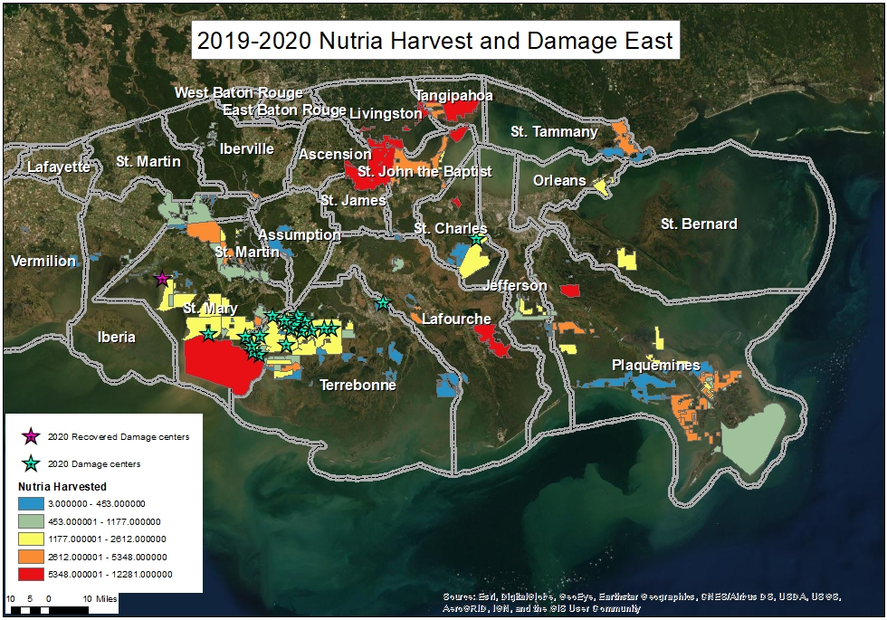

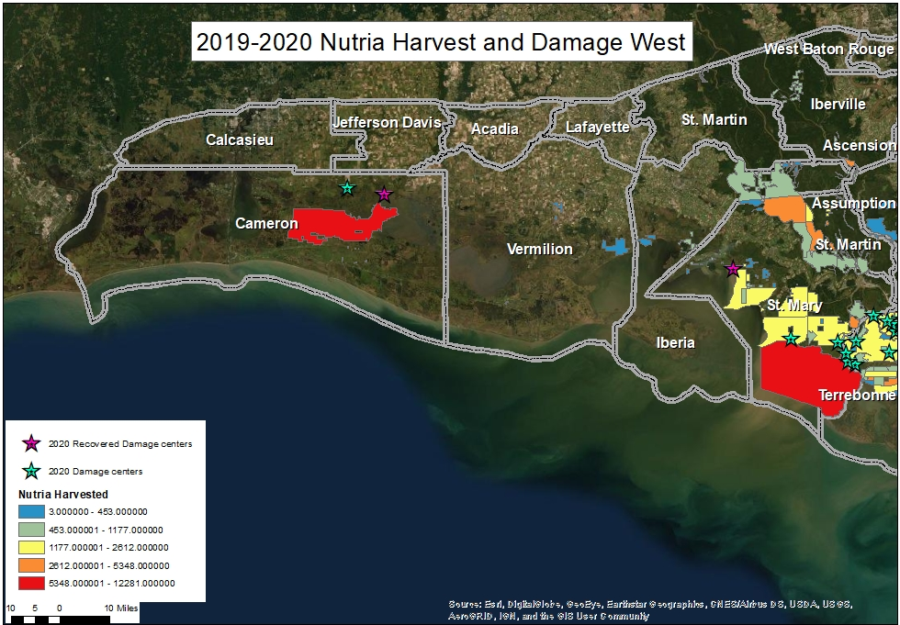

SITE CODE | Parish | MARSH TYPE | LATITUDE | LONGITUDE | DAMAGE TYPE | SECONDARY DAMAGE | 2020 DAMAGE ACRES | ACRES TO OPEN WATER | NRAR | VDR | AGE OF DAMAGE & CONDITION | PREDICTION
9 | Terrebonne | Fresh | 29.58542614 | -91.121963 | Nutria | Hog | 260.87 |  | 1 | 1 | 2 | 0
17 | Terrebonne | Fresh | 29.54474223 | -91.047667 | Nutria |  | 290.95 |  | 1 | 2 | 2 | 0
120 | Terrebonne | Fresh | 29.60744135 | -91.062616 | Nutria |  | 551.71 |  | 1 | 1 | 2 | 0
400 | Terrebonne | Fresh | 29.57713308 | -91.107861 | Nutria |  | 432.69 |  | 2 | 3 | 2 | 0
418 | Terrebonne | Fresh | 29.58118998 | -91.033194 | Nutria |  | 50.20 | 19.24 | 1 | 1,4 | 2 | 0
434 | Terrebonne | Fresh | 29.49484836 | -91.116655 | Nutria |  | 105.98 |  | 1 | 2 | 2 | 0
436 | Terrebonne | Fresh | 29.55545097 | -91.094094 | Nutria |  | 105.33 | 16.83 | 1 | 1,2 | 2 | 0
437 | Terrebonne | Fresh | 29.56799241 | -91.079768 | Nutria |  | 562.46 | 17.47 | 2 | 2,3 | 5 | 0
438 | Terrebonne | Fresh | 29.57826566 | -91.077033 | Nutria |  | 190.83 |  | 1 | 1 | 5 | 0
439 | Terrebonne | Fresh | 29.54842129 | -91.005827 | Nutria |  | 43.60 | 0.62 | 1 | 2,4 | 2 | 0
441 | St. Charles | Fresh | 29.87700761 | -90.292014 | Nutria |  | 48.81 |  | 1 | 1 | 1 | 2
442 | Cameron | Fresh | 29.99204834 | -92.946483 | Nutria |  | 38.74 |  | 1 | 1 | 1 | 2
443 | Terrebonne | Fresh | 29.46925167 | -91.257844 | Nutria |  | 323.00 | 27.01 | 1 | 2 | 2 | 0
444 | Terrebonne | Fresh | 29.52945791 | -91.228256 | Nutria |  | 81.77 |  | 1 | 2 | 4 | 0
445 | Terrebonne | Fresh | 29.45951402 | -91.232265 | Nutria | Hog | 139.47 |  | 1 | 2 | 4 | 0
446 | Terrebonne | Fresh | 29.60421188 | -91.169174 | Nutria |  | 86.58 | 41.19 | 1 | 2 | 4 | 0
447 | Terrebonne | Fresh | 29.59120734 | -91.069099 | Nutria |  | 63.48 | 137.98 | 1 | 1,4 | 2 | 0
448 | Terrebonne | Fresh | 29.55159788 | -90.950254 | Nutria |  | 83.82 |  | 1 | 1 | 2 | 0
449 | Terrebonne | Fresh | 29.55164774 | -90.918924 | Nutria |  | 29.34 |  | 1 | 1,2 | 1 | 2
450 | Terrebonne | Fresh | 29.64287804 | -90.698185 | Nutria |  | 23.39 |  | 1 | 1 | 2 | 2
451 | Cameron | Fresh | 29.97324877 | -92.82023 | Nutria |  | 0.00
452 | St. Mary | Fresh | 29.74737859 | -91.640386 | Nutria |  | 0.00
453 | St. Mary | Fresh | 29.54031459 | -91.448027 | Nutria |  | 79.98 |  | 1 | 1 | 3 | 2
454 | St. Mary | Fresh | 29.526321 | -91.289078 | Nutria |  | 30.22 |  | 1 | 1 | 4 | 0
455 | Terrebonne | Fresh | 29.494462 | -91.26204 | Nutria |  | 30.58 |  | 1 | 1 | 3 | 0
Table 13. 2020 Nutria Vegetative Damage Sites. Nutria relative abundance rating (NRAR): (0) no nutria sign visible, (1) nutria sign visible, (2) abundant feeding sign, and (3) heavy feeding sign; sites converted to open water are not given a NRAR. Vegetative damage rating (VDR): (0) no vegetative damage, (1) minor vegetative damage, (2) moderate vegetative damage, (3) severe vegetative damage, (4) converted to open water. Age of damage and condition: (0) recovered (1) Old recovering (2) old not recovering (3) recent recovering (4) recent not recovering (5) current (occurring now). Prediction: (0) no recovery predicted (1) full recovery (2) partial recovery (3) increased damage.
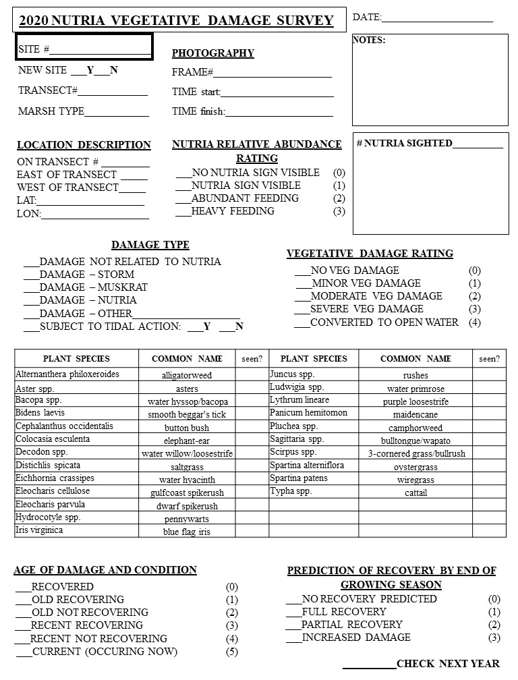

CODES FOR NUTRIA HERBIVORY SURVEY DATA

¹Marsh Type

Fresh F
Intermediate I
Brackish B

²Nutria Relative Abundance Rating ³Vegetative Damage Rating

No Nutria Sign Visible 0 No Vegetative Damage 0
Nutria Sign Visible 1 Minor Vegetative Damage 1
Abundant Feeding Sign 2 Moderate Vegetative Damage 2
Heavy Feeding 3 Severe Vegetative Damage 3
Converted To Open Water 4

⁴Age of Damage and Condition

Recovered 0
Old Recovering 1
Old Not Recovering 2
Recent Recovering 3
Recent Not Recovering 4
Current (Occurring Now) 5

⁵Prediction of Recovery by End of 2019 Growing Season

No Recovery Predicted 0
Full Recovery 1
Partial Recovery 2
Increased Damage 3

